LOCAL GOVERNMENT ACT 2003
BUSINESS IMPROVEMENT DISTRICTS (ENGLAND) REGULATIONS 2004

BUSINESS IMPROVEMENT DISTRICT FOR ALTRINCHAM

DECLARATION OF RESULT – 04/07/2025

As an agent of the ballot holder for the Altrincham Business Improvement District ballot I certify as follows:

Total number of votes cast in the ballot, excluding any given on ballot papers rejected | 226
Aggregate rateable value of each hereditament in respect of which a person voted in the ballot | £8,105,000
Total number of votes cast in favour of the proposed Business Improvement District for Altrincham | 202
Aggregate rateable value of each hereditament in respect of which a person voting in the ballot has voted in favour of the proposed Business Improvement District for Altrincham | £7,555,500

I hereby declare that the proposal to renew a Business Improvement District for Altrincham is approved. A majority of the Business ratepayers in the proposed BID area who voted, voted in favour of the proposal, both by aggregate rateable value and numbers voting.

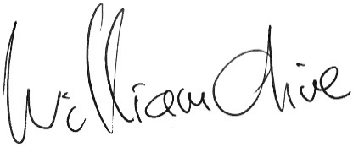
William Olive
Team Manager

Notes:
The total number of ballot papers rejected was as follows:
2 Unsigned, unmarked or void for uncertainty

Total: 2

