Local elections and Police and Crime Commissioner elections - Easy Read
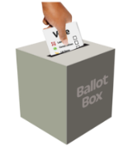 | On Thursday 2 May 2024, there will be Police and Crime Commissioner elections in England and Wales.
 | At these elections you will need to bring photo ID to be able to vote at a polling station.
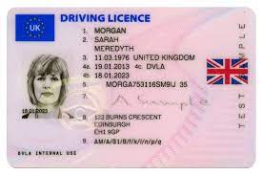  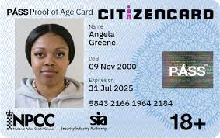  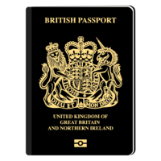 | Lots of photo ID will be ok, like passports, driving licences and cards with a PASS mark on them
 | The name on your ID should be the same name you used to register to vote
 | If you don’t have an accepted form of ID, you can apply for a free voter ID document known as a Voter Authority Certificate
 | You must be registered to vote by 11:59pm on Tuesday 16 April 2024
 | The deadline to apply to vote by post is 5pm on Wednesday 17 April 2024
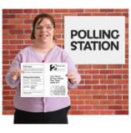 | The deadline to apply to vote by proxy is 5pm on Wednesday 24 April 2024
To find out more information, including which forms of ID will be accepted, how to apply for a Voter Authority Certificate if you need one and what will happen at the polling station:

• visit electoralcommission.org.uk/voterID

• call 0800 328 0280

