Trafford Council

Empty Homes Strategy 2019-2024

Annual Statement 2023

Contents
Introduction 1
Annual Review 2023 1
Strategic Priorities 1
Strategic Context 2
Empty Homes in Trafford 3
Achievements 5
Empty Homes Strategy Action Plan Update 2023 6
Endnotes 14

Introduction
Trafford’s Empty Homes Strategy 2019-2024 was launched in November 2019. The Strategy identifies how the Council, with support from partners, will reduce the number of empty properties within Trafford by bringing them back into use. The Empty Homes Strategy complements the Trafford Housing Strategy 2018-2023 and plays a role in delivering the priorities set out in the GM Housing Strategy 2019-24.

Annual Review 2023
The Trafford Empty Homes Strategy 2019-2024 must be reviewed on a regular basis to ensure effective delivery. This annual review provides an update on the following:
- Strategic Context
- The Number of Empty Homes in Trafford
- Achievements
- The Empty Homes Strategy Action Plan

Strategic Priorities
The following strategic priorities have been identified for this Strategy:

- Work with owners of long-term empty properties to bring them back into use.
- Improve our neighbourhoods by addressing long term empty homes that have become the focus of anti-social behaviour and neglect.
- Provide advice and information to help raise awareness around long-term empty properties.
- Develop effective partnerships with key stakeholders to address long term empty properties.

Strategic Context
Greater Manchester Housing Strategy 2019-2024
The GM Housing Strategy was launched in 2019 shortly after Trafford’s Empty Homes Strategy. It makes reference to the low levels of empty homes across Greater Manchester stating that only 2.5% of all dwellings in Greater Manchester are empty, which is the lowest level recorded since 2004. However, it is recognised that reducing the number of empty homes even further is a viable way to increase housing stock, improve communities, and tackle homelessness. The GM Housing Strategy therefore highlights that the £300m Housing Investment Loan Fund can be accessed to tackle empty homes.
How empty homes can help us reach Net Zero?
Action on Empty Homes (AOEH) published a report in June 2023 on how empty homes can contribute to Net Zero. In June 2022, AOEH began a one-year feasibility study to test and evaluate the viability of three-year local community-led Retrofit Empty Homes Action Partnerships (REHAP).
The purpose of the partnership was to retrofit empty homes, deliver green skills training and build local supply chain markets. The report stresses the importance of community led organisations to include vacant properties without occupants within retrofit schemes, as these homes are important to addressing local housing crises.
Local led action in this context can help to support green job creation, regional supply chain development, local energy generation, and the creation of low-carbon affordable housing. The REHAP framework provides a model for community action, drawing out the key processes and stages of community-based retrofitting.
Representation of data on empty and second homes
Chris Bailey, National Campaign Manager, from Action on Empty Homes wrote to the Statistics Regulator about how the Government was displaying empty homes statistics. The data released appeared to show empty and second homes numbers as just a tiny fraction of their true total of around 1 million.
Following AOEH communications, they advise that the Statistics Regulator has agreed to make improvements that include making data on 200,000 'hidden' Council Tax Exempt empty homes more easily available and more clearly representing data that includes England's 257,000 empty so-called 'second homes' out of residential use.
The second homes are sometimes known as 'furnished empties' and seem to include a variety of types of homes and to be somewhat inconsistently recorded.
The office for statistics regulation published their response on how they were going to rectify the statistical labelling.
Empty Homes and Air BnB’s
In our 2022 Annual Statement, we commented on the impact of empty homes and the use of Air BnB ‘short term lets’ and second homes. The report in 2022 provided by AOEH gave a clear insight that out of the ten boroughs across Greater Manchester, five boroughs have seen an increase in their long-term empty homes.
The data showed that 1 in every 61 homes are empty in Trafford alone. There are increasing concerns that empty homes are being redeveloped or converted into accommodation that is used on a short-term basis rather than benefiting the local demand for housing and reaching the local rental market.
Airdata shows that there are currently 472 active rentals operating through Air BnB and VRBO (another short-term holiday let site) in Trafford. This has almost doubled since the 2022 report. Airbnb-type short lets are the biggest unregulated business in the UK, making billions in income for investors and for Airbnb and the rental platforms.
In Trafford homes used as short term lets:
- Had a 54% occupancy rating (Occupancy rate is calculated by dividing the number of reserved days by the total number of available days in the month for a property.).
- Brought in £23.4k revenue per year (median revenue averaged over last 12 months).
- Charged an average daily rate of £124.30 (how much hosts on the market charged per day averaged over the last 12 months).
Currently, there are no controls on Airbnb’s in England. Government has had two consultations in 2023 that offer some hope of regulating Airbnb operation in England.

Empty Homes in Trafford
DLUHC produces annual data showing how many empty homes there are in each area of the country. This data comes from Council Tax records, so will not include empty properties that are undisclosed to Council Tax nor derelict properties not recorded as dwellings. Despite these limitations, the data is a good indicator of the level of empty properties in each area.
Figure 1 uses the DLUHC data to show 9 shows the number of vacant properties in Trafford from 2018 to 2022. The number of empty properties in Trafford has increased each year since 2018. The figures are reported in calendar year from 1st January to 31st March.

Figure 1: All Vacant Properties in Trafford

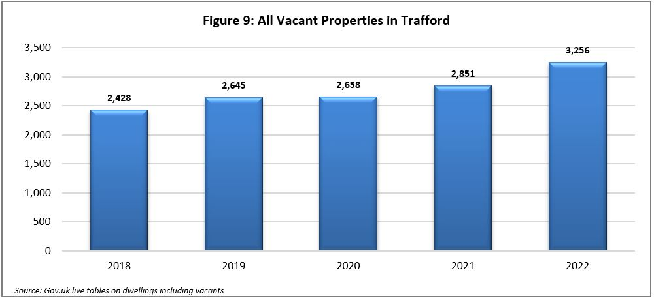
Figure 2 shows the number of long-term empty properties (vacant for over 6 months) in Trafford from 2018 to 2022. The number of long-term empty properties has increased by 38% between 2018 and 2022.
Figure 2: Number of Long-Term Empty Properties in Trafford
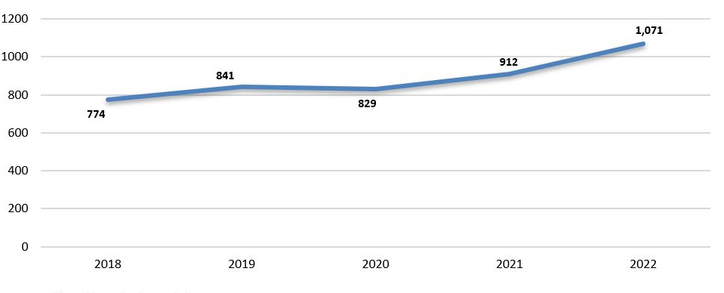

Achievements

Empty Homes Strategy Action Plan Update 2023
A review of the Empty Homes Strategy Action Plan 2019-2024 has been undertaken to determine what has been achieved, what is underway and what still needs to be actioned.

A copy of the Empty Homes Strategy Action Plan update is contained within Appendix A.

What challenges have been faced?
- Post Covid-19 challenges continue to place additional pressures on Housing Standards and Planning Enforcement which continues to divert limited resources away from proactive empty homes work.

- Increased workload in the Housing Standards team has delayed empty property survey work and progression of priority cases. A small number of actions are no longer achievable for the Housing Standards team and have been removed to account for the increased workload.

- Some owners of empty homes who, prior to the Covid-19 outbreak, had given undertakings to complete works leading to renovation and reoccupation or sale of their property, have experienced delays resulting in a lack of progress.

- Homes for Ukraine has increased the demand in workload for the Housing Standards team who must inspect properties when households express interest. This has taken priority over other work.

What has been achieved?
- The ‘scoring matrix’ has been successfully launched and all 163 identified empty properties have now been surveyed.
- A number of properties were found to be reoccupied and there is now a list of 88 empty properties that have been prioritised based on risk, the highest of which will take priority to be brought back into use.
- The ‘scoring matrix’ has identified that often properties which have recently become vacant due to the death of the occupier, and which are going through probate, are the easiest and quickest to sell and bring back into use.
- One high priority long term empty property at Mossgrove Road, Timperley brought back into use
- Work undertaken to identify areas in Trafford with the highest housing need. Old Trafford, Altrincham and Urmston have the highest housing need. Old Trafford needs mainly 2 and 3 bed flats, Altrincham needs 1, 2, 3 and 4 bed houses and Urmston needs 3 bed houses.
- Registered Providers are now notifying the Council when they intend to carry out a disposal.
What is underway?
- Work with owners of long-term empty homes to bring them back into use as affordable housing and emergency/temporary accommodation.
- Identify properties that are long term empty and draw up action plans to return them to use.
- Make better use of the powers and legislation to bring long term empty properties back into use.
- Continue to engage with owners of empty properties to ensure they are fully aware of their options.
- Promote the online reporting form on the Council’s webpage more effectively through social media, to encourage the public to report an empty property in their neighbourhood.
- Work with Registered Providers to identify opportunities to jointly bring empty homes back into use.
- Work with Homes England to identify funding to bring empty homes back into use.
- Work with colleagues across the Council to identify empty properties and agree the most appropriate action to bring them back into use.
- Work to identify suitable empty properties above commercial premises which could be brought back into use as residential properties.
What still needs to be actioned?
- Carry out a pilot initiative in Sale and Stretford, which have the highest number of long-term empties for the longest periods of time and draw up action plans with owners to bring them back into use.
- Investigate the reasons why property owners are not making use of the Empty Property Matchmaker scheme.
- Explore opportunities to use the renovation of empty homes to train and educate individuals regarding the construction trade.

The Empty Homes Strategy Action Plan (2019-2024) will continue to be reviewed and updated bi-annually, and an update report will be produced and published annually.
Appendix A
Trafford Council
Empty Homes Strategy Action Plan
2019-2024

Ref. | Action | By when | By who | Update as of October 2023
ACTION 1: WORK WITH OWNERS OF LONG TERM EMPTY PROPERTIES TO BRING THEM BACK INTO USE
1.1 | Identify areas of highest housing need from the results of the Trafford Housing Needs Assessment. | March 2020 | Housing Standards Team, Housing Strategy & Growth Team | Completed.  Old Trafford, Altrincham and Urmston have the highest housing need. Old Trafford needs mainly 2 and 3 bed flats, Altrincham needs 1, 2, 3 and 4 bed houses and Urmston needs 3 bed houses.
1.2 | Work with owners of long term empty homes to bring them back into use as affordable housing and emergency/temporary accommodation. | Ongoing | Housing Standards Team, Housing Strategy & Growth Team, HOST, Registered Providers | The Housing Standards and HOST team are continuing to identify and consider procuring empty properties that are viable to use as Temporary Accommodation. The teams have inspected two properties and provided a list of works required in order for the property to be leased to HOST.  The Empty Homes Assistance Scheme is no longer in place, and loans will not be available to empty homes property owners. This is primarily due to the lack of uptake and the need to save capital bid funding.
1.3 | Identify properties that are long term empty and draw up action plans to return them to use. | Ongoing | Housing Standards Team, Housing Strategy & Growth Team | The Housing Standards team continue to identify and engage with empty property owners to bring homes back into use.  The Housing Standards team continue to reactively respond to any reports received about empty properties within the Borough and score these according to their condition, to prioritise enforcement action in relation to them. Each property is dealt with on a case-by-case basis, dependent it’s condition, related nuisance/ASB issues and engagement of the owner(s). Housing Standards continue to identify empty properties, with three potential properties being considered for enforcement options.  A further targeted mailshot was going to be considered for empty property loans, however as this scheme is not available anymore this will not be carried out.
1.4 | Carry out a pilot initiative in Sale and Stretford, which have the highest number of long-term empties for the longest periods of time, and draw up action plans with owners to bring them back into use. | December 2023 | Housing Standards Team, Housing Strategy & Growth Team, HOST, Registered Providers | No further action at this time due to other priority work. Housing Standards have identified that this is not something their team is involved with and therefore this action may not be able to be completed.
ACTION 2: IMPROVE OUR NEIGHBOURHOODS BY ADDRESSING LONG TERM EMPTY HOMES THAT HAVE BECOME THE FOCUS OF ANTI-SOCIAL BEHAVIOUR AND NEGLECT
2.1 | Develop a matrix to be used to assess the priority for bringing empty properties back into use and draw up a marking scheme for priority scoring. | March 2020 | Housing Standards Team, Housing Strategy & Growth Team, HOST | COMPLETED  An empty homes scoring matrix has been developed and used to prioritise areas and properties.
2.2 | Identify priority properties to be targeted for action as a result of using priority scoring matrix. | December 2021 | Housing Standards Team, Housing Strategy & Growth Team, HOST, Registered Providers | COMPLETED  All 163 properties have now been surveyed. Some of the properties were found to be reoccupied and there is now a list of 88 empty properties that have been prioritised based on risk, the highest of which will take priority to be brought back into use.
2.3 | Using the matrix to identify those empty properties that can be brought back into use quickly and with limited investment. | December 2021 | Housing Standards Team, Housing Strategy & Growth Team, HOST, Registered Providers | COMPLETED  The matrix is in full use and the Housing Standards Team score all new empty properties reported to us to prioritise those that need to be focussed on more urgently.  Often properties which have recently become vacant due to the death of the occupier, and which are going through probate are the easiest and quickest to sell and bring back into use.
2.4 | Make better use of the powers and legislation to bring long term empty properties back into use. | Ongoing | Housing Standards Team, Housing Strategy & Growth Team, Legal | Housing Standards have drafted procedures for enforcing the sale of and compulsory purchasing empty properties. These are in the final stages of completion with the aim to be in force within the upcoming months. The team continue to serve enforcement notices on problematic empty properties and where applicable, undertake works in default of those notices and place a charge on the property, which is recoverable upon the sale of the property.  The online reporting form is live and has been complete for some time https://www.trafford.gov.uk/residents/housing/housing-standards/Report-an-empty-property.aspx
ACTION 3: PROVIDE ADVICE AND INFORMATION TO HELP RAISE AWARENESS AROUND EMPTY PROPERTIES
3.1 | Continue to engage with owners of empty properties to ensure they are fully aware of their options. | Ongoing | Housing Standards Team, Housing Strategy & Growth Team | The Council website promotes the benefits of bringing long-term empties back into use and how the Council may be able to assist with this, the interest-free loans of up to £10,000 are no longer available , however Housing Standards do respond reactively to complains received and outline what assistance is available from the Council.
3.2 | Promote the online reporting form on the Council’s webpage more effectively through social media, to encourage the public to report an empty property in their neighbourhood. | Ongoing | Housing Standards Team, Housing Strategy & Growth Team, Communications & Marketing Team | Further work in the near future by the Housing Standards Team will be carried out in relation to the publication of the online reporting tool. Other work has taken priority.  The team have been reporting via Trafford News on the website successes which have led to new enquiries from local residents about other empty properties within the Borough.
3.3 | Investigate why there has been a low take up of Council Vacant Home Loans through contact with all owners of properties that have been empty for more than 6 months. | December 2023 | Housing Standards Team, Housing Strategy & Growth Team, | COMPLETED  This scheme is no longer available and therefore action is complete.
3.4 | Explore the opportunity to increase the £10k empty property loan on a case-by-case basis if required to bring back the most challenging of properties. | March 2021 | Housing Standards Team, Housing Strategy & Growth Team | COMPLETED  The Empty Property Loan is no longer available.
3.5 | Investigate the reasons why property owners are not making use of the Empty Property Matchmaker scheme. | December 2023 | Housing Standards Team, Housing Strategy & Growth Team | No further action at this time due to other priority work. This will need to be progressed.
ACTION 4: DEVELOP EFFECTIVE PARTNERSHIPS WITH KEY STAKEHOLDERS
4.1 | Work with Registered Providers to identify opportunities to jointly bring empty homes back into use. | Ongoing | Housing Standards Team, Housing Strategy & Growth Team, SHP, Registered Providers | All the relevant teams continue to work in partnership with the Registered Providers to bring any empty homes back into use. The Housing Standards team are on hand to provide any guidance where necessary.
4.2 | Work with Homes England to identify funding to bring empty homes back into use. | Ongoing | Housing Standards Team, Housing Strategy & Growth Team, Registered Providers, Homes England, SHP | All the relevant teams continue to be aware of Homes England advice and information in relation to empty homes. Any funding that may become available will be utilised by the teams undertaking work on Empty Homes.
4.3 | Work with colleagues across the Council to identify empty properties and agree the most appropriate action to bring them back into use. | Ongoing | Housing Standards Team, Housing Strategy & Growth Team, HOST, Planning Enforcement, Council Tax. | Housing Standards continues to work in conjunction with Planning Enforcement, Estates, Council Tax and Legal teams to try and bring back into problematic empty properties. This work is ongoing and will continue for the duration of the strategy. Council tax provide a list of empty properties which also shows the council tax debt owed, and a joint approach to enforcing sales can take place.
4.4 | Work to identify suitable empty properties above commercial premises which could be brought back into use as residential properties. | Ongoing | Housing Standards Team, Housing Strategy & Growth Team, HOST, Registered Providers, Town Centres Team | Housing standards respond to any reports of empty residential properties. It is not clear who is responsible for commercial properties at this time, and Housing Standards cannot progress this as they are not tasked with this. Further clarification on who within the Council is responsible and whether any further joint working is required.
4.5 | Work in partnership with Registered Providers with housing stock in Trafford in order to ensure that all options are considered when carrying out disposals of empty homes. | Ongoing | Housing Standards Team, Housing Strategy & Growth Team, HOST, Registered Providers | COMPLETED  RPs are now notifying the Council when they intend to carry out a disposal.
4.6 | Explore opportunities to use the renovation of empty homes to train and educate individuals regarding the construction trade. | December 2023 | Employment, Education and Training Task and Finish Group, Housing Standards Team, Housing Strategy & Growth Team, HOST, Registered Providers | No further action at this time. This will need to be progressed within another group or joint working as the Employment, Education and Training Task and Finish Group has been disbanded.

Endnotes

Climate Learning (actiononemptyhomes.org)
Layout 1 (actiononemptyhomes.org)
Housing Numbers Matter - Statistics Regulator Agrees with Concerns about Misleading Government Release | Action on Empty Homes
Publications and Research | Action on Empty Homes
Ed Humpherson to Chris Bailey: Data on empty and second homes in Council Taxbase statistics – Office for Statistics Regulation (statisticsauthority.gov.uk)
CF (actiononemptyhomes.org)
AirDNA
Consultation on a registration scheme for short-term lets in England - GOV.UK (www.gov.uk)
Live tables on dwelling stock (including vacants) - GOV.UK (www.gov.uk)

