Trafford Council

Housing Strategy 2018-2023

Annual Statement 2021/22
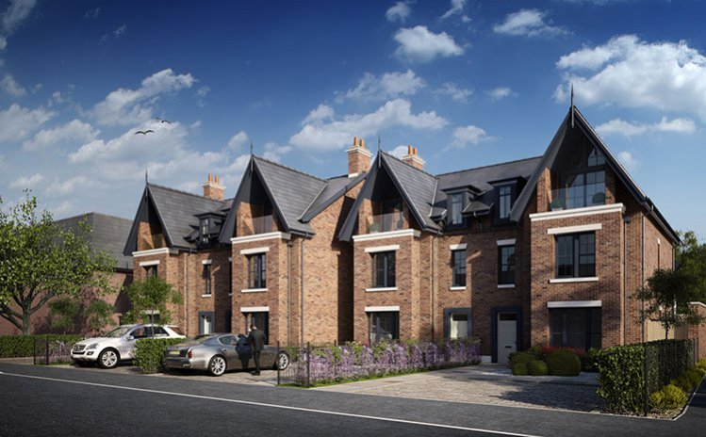
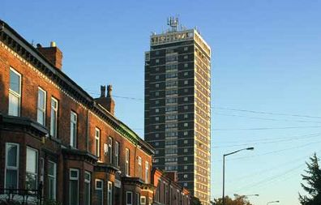
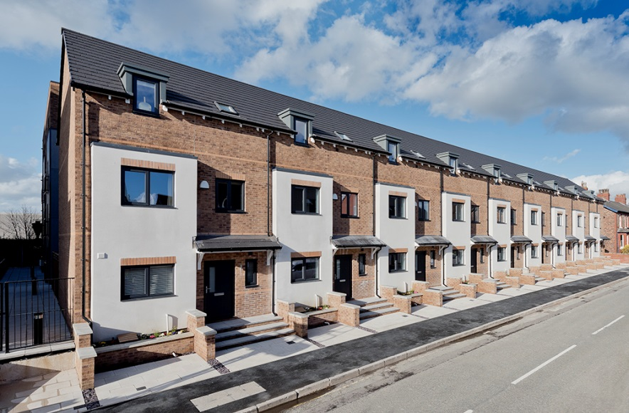
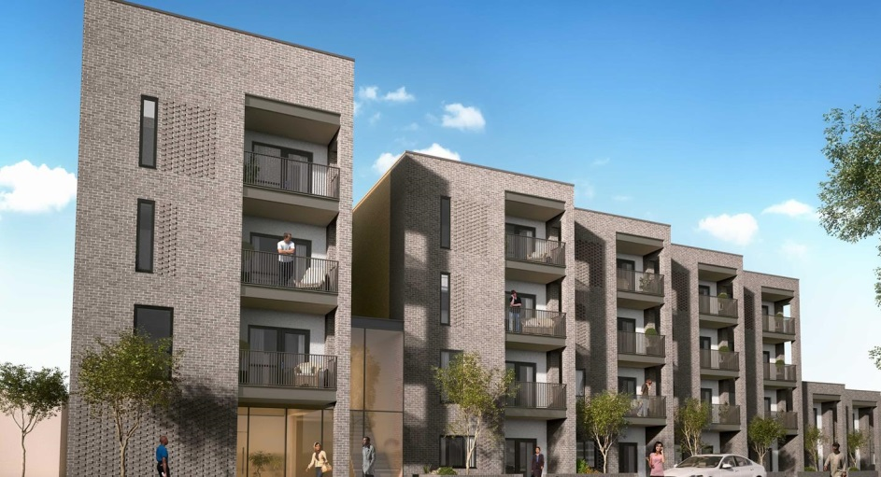
Contents
Introduction 2
Annual Review 2021/22 2
Achievements 2020/21 10
Trafford’s Housing Market 2021/22 12
Delivery of the Housing Strategy Action Plan 26
Housing Strategy Action Plan Update 2021/22 26
Appendix 1 34
Housing Strategy Action Plan 2018-2023 34
Annual Review 2021/22 34

Introduction
Trafford Housing Strategy 2018-2023 was launched in June 2018. The Strategy sets out an ambitious vision for Trafford over a 5-year period up to 2023 and identifies what the Council and our partners plan to do to deliver the housing and neighbourhoods needed in Trafford.

The seven Strategic Priorities are:
- To accelerate housing growth.
- To support inclusive economic growth.
- To create neighbourhoods of choice through a better mix of homes and attractive, accessible environments.
- To reduce inequalities across the borough.
- To improve residents’ health and wellbeing.
- To increase the range of, and residents’ access to, opportunities.
- To reduce homelessness.

Annual Review 2021/22
It is important that the Trafford Housing Strategy 2018-2023 is reviewed on a regular basis.
This annual review provides an update on the following:
- Changes to the national and sub-regional housing policies and strategies.
- The housing market in Trafford 2021/22.
- Delivery of the Housing Strategy.
- The Housing Strategy Action Plan Update:
  - What have we achieved?
  - What are we working towards?
  - What do we still have to do?

Policy and Strategic Context
National Context

There have been a number of new national policies, strategies, initiatives and announcements that have affected the housing sector in Trafford since the Housing Strategy was published in 2018. These include:

Covid-19
Trafford, along with the rest of the country, has experienced unprecedented times since March 2020 due to the Covid-19 pandemic. The Covid-19 outbreak had an impact on households’ ability to retain their homes and its effects continue to be felt. In response to the pandemic, the government initially introduced a number of housing support measures to protect renters and those facing homelessness. These measures included:

- An extension to the length of notice periods that tenants are entitled to. This measure was introduced in March 2020 and was withdrawn in October 2021 when notice periods returned to pre-Covid lengths.

- A ban on evictions which was introduced in March 2020 and remained in place until 31st May 2021. It was speculated that the number of evictions would drastically increase once this measure had been lifted. However, although Trafford has seen a slight increase in the number of evictions since May 2021, the impact has not been as severe as anticipated. Trafford continues to work closely with local private landlords and Registered Providers to support tenants at risk of eviction to prevent homelessness wherever possible.

- An increase to Universal Credit equating to a £20 per week uplift. This measure was removed in October 2021.

- The introduction of the ‘Everyone In’ scheme which required all local authorities across England to provide accommodation for all rough sleepers regardless of priority need status. This scheme was brought to an end in October 2021.

Rough Sleeper Strategy
In August 2018, the government published the Rough Sleeping Strategy which committed to halving rough sleeping by 2022 and eradicating it by 2027. The vision is that by 2027 all parts of central and local government, in partnership with business, the public and wider society; are working together to ensure that no-one has to experience rough sleeping again. Linked to the delivery of this Strategy, the government announced a range of cross-government initiatives which will see the start of new joint working; including a health provision for people who sleep rough and working in prisons to prevent people from sleeping rough in the first place.

In December 2018, the government published a Delivery Plan to set out progress and next steps to meet the objectives of the Rough Sleeper Strategy. Along with detailing what the government was already doing to deliver the Strategy and what its next steps would be, it reiterated the government’s commitment to reviewing the Rough Sleeper Strategy annually from 2019. Unfortunately, due to the Covid-19 pandemic, this review was put on hold. There have since been calls by the National Audit Office and various charities for the review to take place as soon as possible following a more comprehensive understanding of the levels of rough sleeping provided by learnings from the pandemic.

Domestic Abuse Act 2021
The Domestic Abuse Act 2021 was introduced in April 2021. It aims to raise awareness and understanding of domestic abuse and its impacts on victims and their families, improve effectiveness of the justice system in providing protection for victims and bringing perpetrators to justice, and strengthen the support for victims of abuse and their children by statutory agencies. The Domestic Abuse Act places a duty on local authorities in England to provide support to victims of domestic abuse and their children in refuges and other safe accommodation. It amends Part 7 of the Housing Act 1996 to provide that all eligible homeless victims of domestic abuse automatically have priority need for homelessness assistance and requires that local authorities grant a new lifetime tenancy to social tenants leaving existing lifetime tenancies for reasons connected to domestic abuse. Following the introduction of the Domestic Abuse Act, the government also updated the Homelessness Code of Guidance.
Levelling Up White Paper – February 2022
The government has published the Levelling Up White Paper in February 2022 which sets out a large programme of work aimed at tackling geographical disparities across England.

The government has set out four core objectives for levelling up:
- Boost productivity, pay, jobs, and living standards by growing the private sector, especially in those places where they are lagging.
- Spread opportunities and improve public services, especially in those places where they are weakest.
- Restore a sense of community, local pride and belonging, especially in those places where they have been lost.
- Empower local leaders and communities, especially in those places lacking local agency.
The Levelling Up White Paper sets out 12 “missions” that the government will aim to achieve by 2030. In terms of housing, the most relevant mission is:
“By 2030, renters will have a secure path to ownership with the number of first-time buyers increasing in all areas; and the government’s ambition is for the number of non-decent rented homes to have fallen by 50%, with the biggest improvements in the lowest performing areas.”
The initiatives being introduced that effect the housing sector include:
- £1.8bn for brownfield and infrastructure projects will be available across England with a proportion allocated to Mayoral Combined Authorities (MCA) and other local authorities to ‘unlock’ brownfield sites. A further £180m of funding is announced in the white paper for MCAs for locally led brownfield projects.
- Decent Homes Standard is to be extended to the private rented sector.
- Section 21 ‘no-fault’ evictions are to be abolished.

- There is a commitment to increase choices available to older people ‘trapped in non-decent or unsuitable accommodation and a new Task Force will be launched to look at ways better choice, quality and security of housing for older people can be provided, including how to address regional disparities in supply of appropriate and where necessary specialised housing.
- Boosting homeownership with the help of the previously announced £1.5bn Levelling Up Home Building Fund.
- Commitment to build more genuinely affordable housing, through the £11.5bn Affordable Homes Programme, and to introduce a Social Housing Regulation Bill.

Spring Statement 2021
The Spring Statement set out further steps to deliver the Fixing the Broken Housing Market ambition (originally published in 2017):
- Reiterated the government’s commitment to publishing a comprehensive National Infrastructure Strategy – the first of its kind – setting out the government’s priorities for economic infrastructure and responding to recommendations in the National Infrastructure Commission’s National Infrastructure Assessment.
- £717 million from the £5.5 billion Housing Infrastructure Fund to unlock up to 37,000 homes at sites.
- Through the Affordable Homes Guarantee Scheme, the government will guarantee up to £3 billion of borrowing by housing associations in England to support delivery of around 30,000 affordable homes.

Spending Review – November 2021
Key announcements include…
On housing:
- Confirmation of £800m for the Social Housing Decarbonisation Fund, which can be used by housing associations to carry out energy efficiency upgrades in homes.
- Confirmation of £1.8bn to use 1,500 hectares of brownfield land.
- Reconfirmation of the £5bn to remove unsafe cladding from the highest risk buildings, partially funded by the Residential Property Developers Tax.
- Reconfirmation of the £11.5bn Affordable Housing Programme, as part of a multi-year housing settlement of £24bn.
- Confirmation of £639m a year for rough sleeping and homelessness by 2024, a cash increase of 85% compared to 2019-20. Trafford are seeking clarity on this new additional funding and the timing and scope of this commitment.
- An additional £65m investment to improve the planning regime, through a new digital system.

On levelling up:
- The first 105 allocated places are set to receive funding, including for regeneration, from the £4.8 billion Levelling Up Fund.
- Reiteration of plans to publish the Levelling Up White Paper later this year.
- Reconfirmation of the UK Shared Prosperity Fund worth over £2.6bn, focused on funding programmes to help people into jobs in places of greatest need.

On supporting jobs and people:
- By 1 December this year, the Universal Credit taper rate will be cut by 8%, with the work allowance rising by £500.
- Confirmation that skills spending will increase by £3.8bn this Parliament, with a new UK-wide numeracy skills programme announced.

Greater Manchester Context

The Greater Manchester (GM) Housing Strategy 2019-2024 identified decent and affordable housing as a priority. The GM Housing Strategy details how the Mayor of Greater Manchester, the GM Combined Authority (GMCA) and the ten Greater Manchester authorities will maximise the leverage of the resources available to them. Also, the GMCA has agreed to invest surpluses from the £300 million GM Housing Investment Loan Fund to help support the delivery of truly affordable housing, tackle empty homes, and issues in the private rented sector including rogue landlords as contained within the Housing Strategy.

Since the launch of the Strategy, GMCA has developed an Implementation Plan to steer and track progress in the delivery of the agenda set out in the Housing Strategy. It captures activity already underway as well as new lines of work to be commenced in the coming months. The Implementation Plan is updated on a six-monthly reporting cycle, with updates taken to the Greater Manchester Planning and Housing Commission. The most recent update was published at the end of June 2021.

Greater Manchester Homelessness Prevention Strategy
In October 2019, a plan to develop the GM Homelessness Prevention Strategy was approved by the GM Homelessness Programme Board and GM Homelessness Action Network Advisory Board. Despite some unavoidable delays caused by the Covid-19 pandemic, a draft version of the Strategy was published for consultation in May 2021. The Strategy has been co-produced by GMCA and people with lived experiences of homelessness and those who work with them; and takes a person-centred and trauma-informed approach to understanding and responding to issues around homelessness. An Action Plan was launched in October 2021 and will be reviewed every 6 months to identify progress, and once a year to allow for new or amended actions to be included.

Local Context

There have been a number of new local strategies that have affected the housing sector in Trafford since the Housing Strategy was published in 2018. These include:
Trafford Corporate Plan 2021-2024
Trafford Council has recently refreshed its Corporate Plan and created a new overarching vision: “Trafford – Where our residents, communities and businesses prosper”. This vision will ensure Trafford builds back better out of the Covid pandemic to develop a borough fit for everyone. To achieve this vision, three new corporate priorities have been set:

- Reducing health inequalities: Working with people, communities and partners, particularly in deprived areas, to improve the physical and mental health of all our residents.

- Supporting people out of poverty: Tackling the root causes to prevent people from falling into poverty and raising people out of it.

- Addressing our Climate Crisis: Reducing our carbon footprint and tackling the impact of climate change.

The Corporate Plan 2021-2024 details how performance will be measured in respect of delivering on these priorities and outlines a commitment to produce quarterly reports on how successfully the priorities are being achieved.
Empty Homes Strategy 2019-2024
The new Empty Homes Strategy (2019-2024), launched in November 2019, has been produced to identify key priorities and actions to be delivered by the Council and other stakeholders over the next five years to bring empty homes back into use across Trafford Council area.
The vision for the Empty Homes Strategy 2019-2024 is: “Work together to bring Trafford’s long term empty properties back into use to increase the supply of quality, affordable homes for our residents”.
The strategic priorities are:
- Work with owners of long-term empty properties to bring them back into use.
- Improve our neighbourhoods by addressing long term empty homes have become the focus of anti-social behaviour and neglect.
- Provide advice information to help raise awareness around long-term empty properties.
- Develop effective partnerships with key stakeholders to address long term empty properties.
Older People’s Housing Strategy 2020-2025
The Older Peoples’ Housing Strategy (2020-2025), launched in February 2020, has been produced to identify key priorities and actions to be delivered by the Council and other stakeholders over the next five years. The aim of the Strategy is to deliver an integrated approach to the housing needs of older people in the borough. This includes a focus on enabling older people to remain in their own homes and to make active and informed choices where necessary or desired. It also includes a focus on suitable housing, care, and support, while maximising independence and quality of life.
The Strategy identifies some key themes to improve the range and quantity of housing provision for older people and contains an action plan and priorities for the Council to explore.
The vision for the Older Peoples’ Housing Strategy 2020-2025 is: “Work together to provide a range of quality, affordable and attractive housing options to enable older people to live independently in Trafford”.
The strategic priorities are:
- Improve the quality and standard of existing housing for older people in Trafford.
- Increase the availability and range of suitable housing options for older people within Trafford.
- Enable older people in Trafford to live independently.
- Create and foster partnerships that work to deliver effective health and social care provision, support services and high-quality housing to older people across Trafford.
Trafford Supported Housing Strategy 2022-2027
The Trafford Housing Strategy 2019-2023 highlighted a need to produce a Supported Housing Strategy to determine current and future need for supported housing in Trafford. Trafford Council began drafting the Supported Housing Strategy in 2019, but progress was delayed by the Covid-19 pandemic. In 2020, the draft was refreshed updated and included the addition of a section focusing on domestic abuse in light of the implementation of the Domestic Abuse Act 2021. In September 2021, an initial consultation was carried out with both residents and stakeholders with the findings utilised to help formulate a full draft Supported Housing Strategy.
Trafford Council is intending to consult on the draft Strategy in early 2022 with expected publication in autumn 2022.
Trafford Together Locality Plan 2019-2024
The Locality Plan 2019-2024 is the blueprint for the transformation of health and social care over a 5-year period. This is part of a wider Trafford Partnership which includes the many areas of change that health and social care is part of to share resources and aspirations. The plan is set around four main principles:
- our population,
- the people we serve,
- the place where we live and work and,
- the partnerships we create.

The objective is to improve the lives of the most vulnerable, to improve the wellbeing for all residents, and to improve connections across communities. Central to this is a belief that people should be supported to live independently in their own homes for as long as possible, remaining connected to families, friends, and their local communities.

Trafford Domestic Abuse Strategy 2022 – 2025
This Strategy sets out Trafford’s vision of enabling our residents, their families, and communities to live a healthy life, free from abuse and violence. The Strategy outlines that this vision will be supported by reducing the impact of domestic abuse on the population of Trafford by developing and implementing a sustainable system wide approach to prevention, early intervention, response, and support.
The Strategy outlines four priorities that will enable Trafford to work towards a long-term response that meets the needs of victims, their children, and perpetrators across the borough. These are:
- Ensure that every victim is identified early and has access to the support they need.
- Ensure the support for families is co-ordinated.
- Ensure that communities are able to spot the signs of abuse and know where to get help.
- Ensure multi-agency system is joined up so that individuals, families and communities who seek support can find it, and access it.
The Strategy also sets out thirteen objectives which will be used to work towards delivering the strategies priorities. The objectives will be delivered by the Domestic Abuse Partnership through an implementation plan which is contained within the Strategy’s appendix. An annual report will be produced annually outlining achievements and providing a refreshed implementation plan.

In line with Part 4 of the Domestic Abuse Act 2021, Trafford Council established a Domestic Abuse Partnership Board in July 2021. The Board is made up of representatives from Community Safety, Public Health, Commissioning, Adult and Children’s Social Care, Housing, Education, Emergency Services (police, fire, and ambulance), Probation, TDAS, Women MATTA, LGBT Foundation, and Talk Listen Change. The Board is responsible for providing advice to the Council about the exercise of the functions under section 57 of the Domestic Abuse Act 2021, and the provision of other local authority support in the authority’s area. The functions of the Board are to assess the need for accommodation-based support in Trafford, prepare and publish a Strategy for the provision of such support, and monitor and evaluate the effectiveness of the Strategy.

Achievements 2020/21

47 new build affordable residential units completed in 2020/21 which is an increase of 10% from the previous year

Council owned site at the former Sale Magistrates Court has 86 new homes planned in partnership with THT and Seddon’s underway.

1,130 new build residential units completed in 2020/21 which is an increase of 155% from the previous year

Sale West Masterplan developed by Irwell Valley Homes to address sites within their estate

Trafford Council has established a development team who are leading on acquiring sites for development and/or investment.
Masterplans for Old Trafford, Stretford (Civic Quarter) & Carrington have been developed to bring forward large strategic sites.

79 social rented properties are under development on the Sale West estate with Irwell Valley

30, 1 and 2 bed social rent apartments funded by the Trafford Affordable Housing Fund has been developed by THT.
The Trafford Affordable Housing Fund was established to bring together S106 monies for affordable housing off-site contributions from developers.

New Student Accommodation at the former Warwick House has been completed (academy Apartments) to provide UA92 1st year students accommodation

Housing Propositions for the seven sub areas of Trafford have been created and published

The Trafford Housing Need and Demand Assessment was commissioned.

Achievements 2020/21

Trafford’s new Homelessness Strategy launched in March 2019.

HOST successfully transferred back to the Council 1st April 2021

Empty Property Strategy launched to tackle Trafford’s long term empty properties

41,392 housing advice queries received in 2020/21

303 households prevented from becoming homeless in 2020/21

Average length of stay in B&B for families reduced from 16 days in 2019/20 to 9 days in 2020/21

79 social rented Consultation with older residents has been undertaken to determine current and future housing need.

Older People’s Housing Strategy developed to increase the provision of housing for older people to enable them to live independently.

Draft Supported Housing Strategy 2022 - 2027 created.

Trafford Council has re-established a Private Landlords Forum to improve links and engage with landlords

The Trafford Private Sector Stock Condition Survey was commissioned

Empty Homes Strategy created and published.

Trafford’s Housing Market 2021/22
House Prices

Figure 1 shows the average house price in all boroughs within Greater Manchester (GM) in quarter 3 2021/22. It shows that housing in Trafford continues to be in high demand, stimulating a buoyant local housing market. The value of residential property in Trafford continues to be the highest in GM. This demand is led by families seeking access to high achieving local schools and people looking to easily access the major leisure facilities in Trafford, as well as Manchester City Centre and the universities.

Table 1 shows the average sale price of different types of residential property across the ten Local Authority areas of GM. Trafford properties continue to hold the highest value across all housing categories when compared to the rest of the borough.

 | Table 1: Average House Sale Prices in GM Q3 2021/22
 | All Properties | Detached | Semi Detached | Terraced | Flats/ maisonettes
GM | £210,171 | £367,997 | £234,305 | £168,427 | £161,268
Trafford | £334,352 | £630,312 | £368,458 | £280,496 | £204,451
Stockport | £271,294 | £471,662 | £289,241 | £206,502 | £160,281
Manchester | £211,773 | £388,225 | £264,527 | £199,637 | £180,746
Bury | £221,567 | £376,549 | £240,178 | £171,794 | £122,205
Salford | £195,663 | £365,045 | £235,000 | £173,522 | £154,430
Tameside | £191,113 | £329,973 | £209,762 | £158,293 | £121,580
Rochdale | £173,536 | £297,325 | £183,562 | £134,654 | £92,964
Oldham | £168,606 | £301,410 | £188,826 | £137,234 | £120,024
Bolton | £172,820 | £311,309 | £184,488 | £136,678 | £106,537
Wigan | £167,529 | £281,974 | £168,245 | £127,850 | £89,920
Land Registry UK House Price Index

Figure 2 shows house values in Trafford from March 2017/18 to March 2021/22. House values in the borough have decreased slightly between March 2020/21 and March 2021/22, which is likely the result of the Covid-19 pandemic. It is anticipated house values will again increase when the next update is available in March 2022.

Figure 3 shows that, as of October 2021, the annual average house price in Trafford has increased by 9.41%, which is the second lowest increase in Greater Manchester. House prices in Tameside, Bury, and Bolton have seen the greatest percentage increase change.

Figure 4 shows that there has been a decrease in the number of house sales in Trafford from 2019/20 to 2020/21. This is likely the result of the temporary shutdown of the housing market in 2020 due to Covid-19. The next update on this figure will be April 2022, when it is anticipated that sale volumes will have increased.

Private Rented Housing

Figure 5 shows the average rents of private properties in Trafford, by bedroom size, when compared to GM rents overall. As demonstrated, rents for all size private properties in Trafford are higher than the GM average with the exception of 1-bedroom properties.

Figure 6 shows the average monthly rent of private properties in Trafford by sub area and bedroom size. As shown, private rents are considerably higher in the Rural Communities and Altrincham compared to the rest of Trafford.

Local Housing Allowance (LHA) is used to calculate how much Housing Benefit or Universal Credit Housing Element a claimant can receive if they rent from a private landlord. The LHA rate is set by calculating the number of bedrooms a tenant can claim for under government rules.
The Valuation Office Agency (VOA) sets the LHA rate for all areas. Trafford LHA rates fall into two geographical areas – Central GM BRMA which covers the North Trafford area (Stretford, Urmston, and Flixton) and Southern GM BRMA which covers the South Trafford area (Sale, Partington, Carrington, Altrincham, and Hale). LHA rates across the country were increased in April 2020 in response to the Covid-19 pandemic, but this measure was removed in April 2021 following the Government’s Spending Review.
Trafford’s LHA allowances (as of January 2022) per month, to the nearest pound, are:

 | North Trafford | South Trafford
1 Bedroom | £598 | £524
2 Bedroom | £648 | £648
3 Bedroom | £722 | £748
4 Bedroom | £947 | £1,097

Figures 7 and 8 show the LHA rate (to the nearest pound) compared against average rent prices in the private sector in both LHA geographical areas. The data shows the disparity between Housing Benefit/Housing Element and private rents in Trafford.

Figures 7 and 8 highlight that Trafford’s private rented properties are largely inaccessible for those in receipt of welfare benefits as the LHA rates are significantly less than the average monthly rents in all areas for all size properties.

Empty Properties

Figure 9 shows that the number of empty properties in Trafford has gradually increased since 2017. The figures are reported in calendar year from 1st January to 31st December and published annually in March. The next update will be available in March 2022.

Figure 10 shows the number of properties classed as long-term empty (vacant for over 6 months). Between 2019 and 2020, the number of long-term empty properties in Trafford decreased slightly for the first time since 2015. The figures are reported in calendar year from 1st January to 31st December and are published annually in March.

New House Building

Figure 11 shows the number of residential dwellings constructed by private developers and housing associations in Trafford compared to in GM overall. The figures are reported in calendar year from 1st January to 31st December and published annually in March.

It should be noted that this data is taken from the gov.uk statistical data set ‘live tables on housing supply: indicators of new supply’, which only includes new builds. Trafford Council keep their own record of all completed dwellings which indicates a total of 1,308 additional dwellings were completed in 2020.

Figure 12 shows the total number of completions during Q3 2021/22 with Altrincham being the area with the highest number of completions; 30 units at Bowker Court, 2 units at 92-94 Park Road, 2 units at Greenbank House (15 Albert Square), and 1 unit at 75 Oakfield Road.

The negative figure displayed for Rural Communities is due to the development at Dunham House (Charcoal Road) where a block of flats was converted into a single dwelling resulting in a net loss of 7 units. However, due to the completion of 1 unit at Manor House, 10 Theobald Road, the total completions figure for Q3 in Rural Communities is -6.
Figure 12: Number of completions in Q3 2021/22
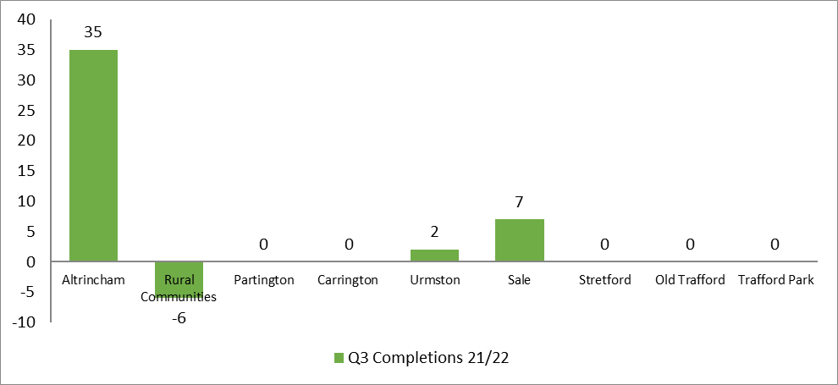

Table 2 shows the total completions recorded by the Housing Tracker and the SHLAA, per quarter, for 2021/22.

Table 2: Total completions from Housing Tracker and SHLAA 2021/22
2021/22 | Housing Tracker Net Unit Completions | Housing Tracker Gross Unit Completions | SHLAA Gross Unit Completions
Q1 | 72 | 79 | 132
Q2 | 101 | 103 | 137
Q3 | 38 | 62 | 214

In quarter 3 2021/22, the SHLAA recorded the following completions that were not included in the Tracker completions. This is because the SHLAA records completions by unit whereas the Tracker records per development.

- 37 units completed at the Former Itron Site (Stretford). This site is still under development and will provide a total of 282 units once fully complete.

- 89 units completed at the Cornbrook Works (Old Trafford). This site is still under development and will provide a total of 363 units once fully complete.

- 24 units completed at Heath Farm (Partington). This site is still under development and will provide a total of 148 units once fully complete.

Figure 13 shows the total number of potential new units that have been granted planning permission as of quarter 3 2021/22. Old Trafford is the area with the most potential net new units with large developments granted planning permission at Pomona Strand, Cornbrook Works, Trafford Plaza, and Elsinore Road/Skerton Road.

Figure 13: Potential net new units Q3 2021/22
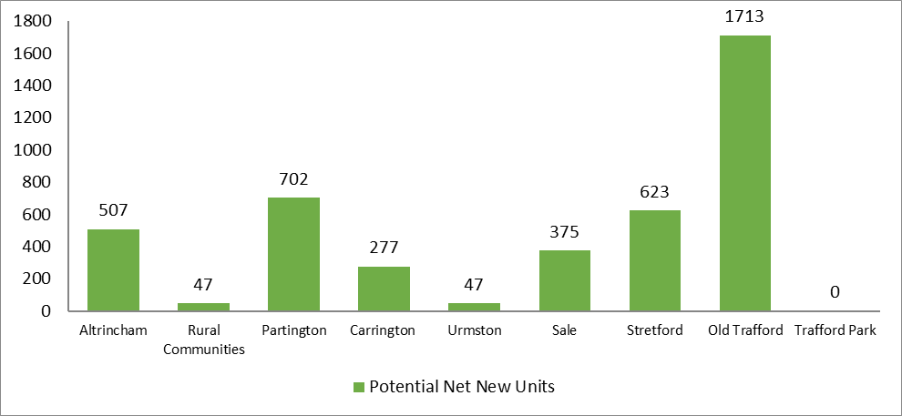

Figure 14 shows the total potential net new units along with the total number of units that have commenced on site as at 31st December 2021. For the purpose of this graph, the number of units on site is the total number that is detailed on the planning permission rather the total number that is actually being built i.e. a site may have 100 units on the planning approval but is only on site with 5 currently; in this case the graph will show the total number of units (100) as on site. The area with the highest number of units on site is Old Trafford which includes the large development at Pomona Strand (Phase 2).

Figure 14: Total number of units (as shown on planning approval) commenced as at Q3 2021/22
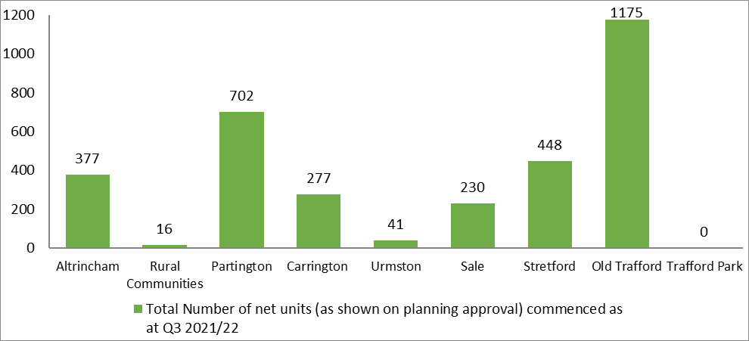

Officers within the Strategic Growth Service make regular contact with developers and/or landowners where schemes have not commenced works on site to determine the reason for the delays. Figure 15 shows the sites by area where works have not commenced as of 31st December 2021.
Figure 15: Number of units not commenced
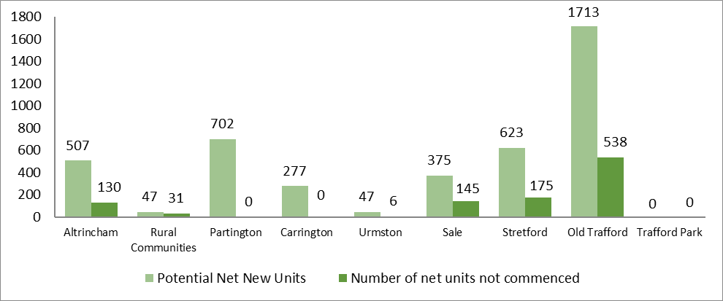

Sites with Outline Permission are recorded separately to provide a more accurate figure on forecast net new units and commencements. There are a total of 15 developments (3,925 units) that have been granted Outline Permission across Trafford.

Figure 16 shows the total number of net units that have been granted Outline Permission for each area. Trafford Park has the highest number of units granted Outline Permission, all of which relate to the ‘Trafford Waters’ development.

Figure 16: Number of net units granted outline permission
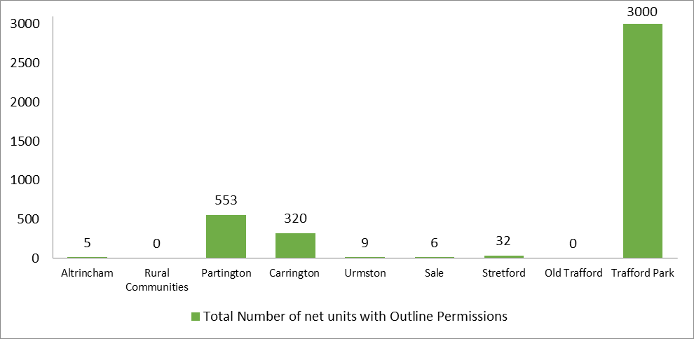

Housing Affordability

Figure 17 shows that house prices for residential property in Trafford were almost 9 times the average salary in 2020 (average gross salary is £36,500 in Trafford). Since most lending institutions will traditionally lend up to four and a half times the household annual salary (for the purpose of buying a house with a mortgage) this would mean that a household would need to have a yearly income of at least £73,000 to purchase a property in Trafford.

The ratio is produced by dividing the house prices in Trafford by the average earnings of the area. This indicator is reported annually and published in March each year.

Affordable House Building

Figure 18 shows the number of additional affordable housing units constructed in 2018/19, 2019/20, and 2020/21 in each borough within GM. In total, Trafford has developed 227 affordable units over this timeframe. The figures are reported in calendar year from 1st January to 31st December. The next available update will be available in December 2022.

Figure 19 shows the percentage change from 2019/20 to 2020/21 with regards to the number of additional affordable housing units in all boroughs within GM. In Trafford there was a 62.5% decrease of new affordable housing built, which was the greatest annual percentage change. The figures are reported in calendar year from 1st January to 31st December. The next available update will be available in December 2022.

Figure 20 shows the number of affordable units planned as per the planning application alongside the number of affordable units that have commenced on site. The largest number of affordable units are being delivered in Partington (290 units) and Sale (155 units). All affordable units in Partington, Carrington, and Urmston have commenced as of 31st December 2021.
Figure 20: Number of affordable units being delivered on site (as per planning approval) and number commenced as of Q3 2021/22
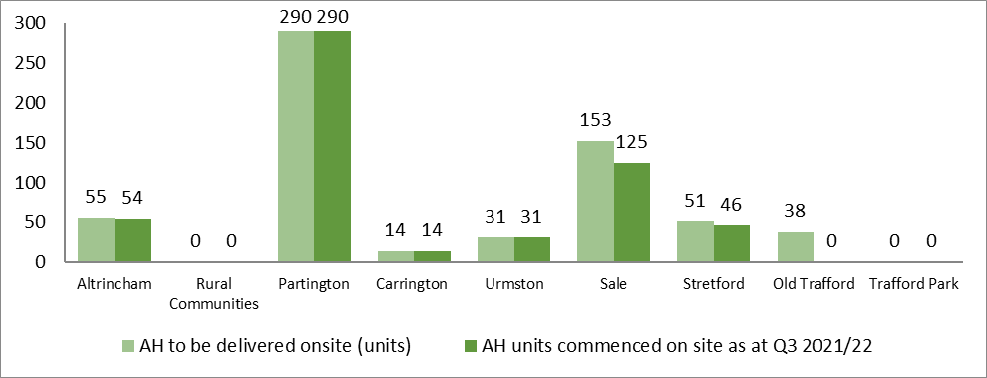

The following tables provide more detail on the schemes providing affordable housing by sub-area along with their status as of 31st December 2021.

Table 3: Affordable housing to be delivered in Altrincham
Address | Total net units as per planning permission | Net AH units | Status
46-50 Railway Street | 29 | 9 | Started on site
Land on Wharf Road | 99 | 20 | Started on site
Chapel House  14 New Street | 15 | 15 | Started on site
Refuse Collection Depot  Wharf Road | 49 | 10 | Started on site

Table 4: Affordable housing to be delivered in Partington
Address | Total net units as per planning permission | Net AH units | Status
Greyhound Hotel  Manchester Road | 24 | 24 | Started on site
Land at Lock Lane / off Hall Lane | 161 | 77 | Started on site
Land adjoining Manchester Ship Canal North and Thirlmere Road | 298 | 40 | Started on site
Land at Oak Road | 76 | 76 | Started on site
Land at Heath Farm Lane | 148 | 74 | Started on site

Table 5: Affordable housing to be delivered in Carrington
Address | Total net units as per planning permission | AH units | Status
Land known as Carrington Village  (Land off Manchester Road) | 277 | 14 | Started on site

Table 6: Affordable housing to be delivered in Urmston
Address | Total net units as per planning permission | AH units | Status
50 -78 Higher Road | 31 | 31 | Started on site

Table 7: Affordable housing to be delivered in Sale
Address | Total net units as per planning permission | AH units | Status
319 – 365 Norris Road | 38 | 38 | Started on site
Sale West Estate  Bounded by Firs Way, Cherry  Lane, Woodhouse Lane, and Manor Avenue | 79 | 79 | Started on site
Crossford Court  Dane Road | 39 | 8 | Started on site
Former Magistrates Court  Ashton Lane | 84 | 21 | Not started
Mayfield House Danefield Road and The Lodge  Dane Road | 29 | 7 | Not started

Table 8: Affordable housing to be delivered in Stretford
Address | Total net units as per planning permission | AH units | Status
64 – 66 Talbot Road | 149 | 33 | Started on site
Former Itron Site  Talbot Road | 282 | 13 | Started on site
Former Royal Canal Works  South of Edge Lane | 47 | 5 | Not Started

Table 9: Affordable housing to be delivered in Old Trafford
Address | Total net units as per planning permission | AH units | Status
Land bound by Elsinore Road and Skerton Road | 367 | 37 | Not started

As of quarter 3, 44 units of affordable housing have been completed in 2021/22. This includes the redevelopment of the library at 405 Stockport Road in Altrincham which provided 14 shared ownership apartments and the newly built Bowker Court in Altrincham which provided 30 new social rent apartments.

Social Housing Demand

At the end of quarter 3 (31st December 2021) there were 6,445 applicants on Trafford Council’s Housing Register. Once registered for social housing, applicants are placed into different priority bands depending on their housing need. Applicants in Band 1 are deemed to be in the highest need for social housing. Figure 21 shows the breakdown of total applicants by priority band. Over half (46%) of all applicants are in Band 4, which accounts for those who are eligible to join the housing register but do not have any identified housing need.

Bandings Definitions
Band 1: Urgent need to move and owed Reasonable Preference
Band 2: Need to move and owed Reasonable Preference
Band 3: Owed Reasonable Preference but do not meet criteria for Bands 1 & 2
Band 4: No housing need but meets meet the Trafford Positive Community Criteria
Band 5: Reduced preference due to rent arrears, behaviour, no local connection, has savings, equity or earnings above agreed thresholds

Figure 22 shows the number of bedrooms required to fulfil all applicants’ housing need requirements. The data shows that most applicants require a 1-bedroom (55%) property.

Delivery of the Housing Strategy Action Plan
The delivery of the Housing Strategy Action Plan is being led by the Strategic Housing Partnership (SHP). A number of Task & Finish groups have been established to drive forward the delivery of the Action Plan, which include:
- Housing Propositions
- Private Sector Housing
- Student Accommodation
- Increase Housing Delivery
- Older People
- Homelessness
- Employment, Training, Education & Social Value

Housing Strategy Action Plan Update 2021/22
A review of the Housing Strategy Action Plan 2018-2023 has been undertaken to determine what has been achieved, what we are working towards, and what we have still left to do. A copy of the Housing Strategy Action Plan update is contained within Appendix 1.
What have we achieved?
Increase housing delivery
- Increase Housing Delivery - 1,130 new build residential units have been completed during 2020/21 which is an increase of 155% when compared to the previous year.

- Increase Housing Delivery - Increase Housing Delivery Task & Finish Group has been established which includes landowners (Peel & Himor), developers, Registered Providers, Highways England, TfGM, CCG, Education and Planning. The group has met twice and are looking at what the main barriers to bringing development forward and the delivery of the large strategic sites (Carrington and Trafford Waters).

- Establish a Trafford Housing Fund to provide additional financial support for housing priorities as identified through the housing propositions - The Trafford Affordable Housing Fund was established in September 2018. The Fund combines all affordable housing planning contributions made via a S106 and enables Registered Providers to bid to the Fund to increase the provision of social rented accommodation in Trafford.

- Partner with the private sector (including Registered Providers) to deliver new homes - A bid has been submitted by Trafford Housing Trust for the Affordable Housing Fund which was approved for the provision of 30, 1 and 2 bed apartments for social rent. These apartments completed in December 21.

- Identify, utilise, and deploy Council assets (land and buildings) to bring forward more sites for residential development - The Council’s Development Team in partnership with Seddon’s and Trafford Housing Trust have been granted planning application for 86 new homes on the site of the former Sale Magistrates Court.

- Develop a master-plan led approach to appropriate large/strategic sites - Masterplans for sites in Old Trafford, The Civic Quarter, Carrington, and Stretford are in place and work is underway with partners such as THT in Old Trafford and Himor in Carrington to bring forward the large sites identified.

- Develop a master-plan led approach to appropriate large/strategic sites - Sale West Masterplan developed by Irwell Valley Homes to address sites within their estate.

- Develop a master-plan led approach to appropriate large/strategic sites - Village Plans are being developed for Sale Moor and Hale.

- Introduce and extend the type and range of affordable housing products to meet all housing needs - the results of the Housing Need Assessment have enabled the Council to produce area-based Housing Propositions that include the affordable housing requirements for each area. The discussions regarding affordable housing products required will continue to take place with Registered Providers.

- Proactively identify, negotiate, and where appropriate acquire sites to speed up development - Trafford Council has established a development team who are leading on acquiring sites for development and/or investment. Acquisition of Stretford Mall, Grafton Centre and Sale Magistrates has already taken place.

- Where appropriate package sites to deliver more housing / improved mix / improved viability - Trafford Council is working with Trafford Housing Trust on the development of the Tamworth area in Old Trafford which has involved a Joint Venture approach with the packaging of sites from THT and the Council together.

Rebalance the housing offer across Trafford
- Undertake a Housing Need and Demand Assessment (HN&DA) for Trafford - The Trafford Housing Need and Demand Assessment was commissioned in 2019 and the final report received January 2020.

- Develop a set of ‘Housing Propositions’ for each of Trafford’s places and communities - Housing Propositions from the seven sub areas of Trafford (Carrington & Partington, Sale, Stretford, Old Trafford, Altrincham, Rural Communities and Urmston) have been created and published.

Address and meet the housing needs of older people
- Consult with older residents to establish their housing, support and future care needs - Consultation with older residents has been undertaken to determine current and future housing need. The consultation results have fed into the production of the Older Peoples’ Housing Strategy.

- Develop an Older Peoples’ Accommodation Strategy - Trafford Older Peoples’ Housing Strategy and Action Plan was launched March 2020 and Older Peoples’ Housing Task & Finish Group established to drive forward the delivery of the Action Plan.

Develop a planned and quality housing offer for students
- Complete the master-planning exercise for ‘UA92’ - The Civic Quarter Plan has been prepared which sets out the type and amount of development in the area from Stretford Leisure Centre to Trafford Bar Metrolink Station.

- Develop a Place Plan and Housing Propositions for Stretford and its surrounding areas - Housing Proposition for Stretford and Old Trafford has been developed and published. The Propositions include details regarding the right type, size and tenure of accommodation needed to re-balance the housing market and includes student accommodation.

- Explore the impact of an increased student population in Stretford, Old Trafford and beyond - A UA92 Welfare Workstream has been established and has taken the format of quarterly meetings and most recently a workshop including several stakeholders including CCG, CFW, GMP and GMFRS to understand the immediate and potential needs of the student population.

- Support the appropriate development of new bespoke student accommodation and health provision - Trafford Council worked with Beech Properties to provide bespoke Student Accommodation for the first year’s intake at UA92, which is provided at the former Warwick House, renamed Academy Apartments. These apartments provide accommodation for year 1 students of UA92.

Improve existing homes
- Undertake a stock condition survey to establish an up-to-date picture of the condition and quality of homes within the borough and assess any impacts upon health - The Trafford Private Sector Stock Condition Survey was commissioned and the report completed in June 2019. The data and results from this survey will be used to develop area-based action plans to address property conditions and energy efficiency in the borough.

- Establish a multidisciplinary approach to both identifying and addressing problems in the private sector - A multi-agency approach to private sector accommodation has been established through the Private Sector Task & Finish Group.

- Improve liaison and links with private landlords through the establishment of a Private Landlords Forum - Trafford Council has re-established a Private Landlords Forum to improve links and engage with landlords.

- Develop a new Empty Property Strategy and Action Plan - Trafford Empty Homes Strategy launched in November 2019.

- Explore affective and cost-efficient ways and mechanisms of bringing empty properties back into use - The Trafford Empty Property Matchmaker Scheme was launched.

Provide support for the people who need it
  - Revise Trafford’s Homelessness Strategy - Trafford Homelessness Strategy launched in March 2019. The Homeless Champions Group is leading on the delivery of the Homelessness Strategy Action Plan (2019-2024) and several Task & Finish Groups have been established.
  - Review and assess the likely impact of the Homelessness Reduction Act upon the Council’s resources - A review of the impact of the Homelessness Reduction Act (HRA) has taken place and the Housing Options Service Trafford (HOST) contract has been modified to reflect the new legislative requirements.
  - Implement a new GM ICT caseload system for homelessness - New ICT system is in place across GM to monitor and manage the homelessness caseload and the Homelessness Reduction Act.
  - Ensure access to and awareness of local services Through the Trafford Service Directory - Trafford Service Directory publicised is by HOST.
What are we underway with?

Increase housing delivery
- Identify, utilise, and deploy Council assets (land and buildings) to bring forward more sites for residential development - A review of Council Land and Assets is underway. At the Increase Housing Delivery Task & Finish Group the estates team reports quarterly on those sites that are available and going to the market, so that partners are aware.

- Research and explore opportunities to deliver accommodation through non-traditional methods of construction – officers within the Housing Strategy & Growth Team have visited a number of modular house building factories and are encouraging RPs to develop modular housing as part of schemes. In addition, a representative from Ilke Homes regularly attends the Increase Housing Delivery Task & Finish group.

- Research and explore opportunities to deliver more self and customer build properties – work is underway in Strategic Planning regarding the Council’s obligations as contained within the Self and Custom Build Act. Appropriate sites are being identified and will then be offered to those applicants on the Self-Build Register to purchase.

- Work with investors to deliver more bespoke build to rent accommodation - Work is ongoing to develop relationships with investors to increase the provision of bespoke build to rent accommodation

- Research and explore the potential in Trafford for Community Land Trusts - Community Land Trusts provide great benefits to communities. However, there are not any Trust opportunities within Trafford currently. Discussions with the National Trust in relation to creating a Community Land Trust in Trafford have taken place, however this was a pre-Covid and is a conversation that needs to be picked back up.

Rebalance the housing offer across Trafford
- Regularly review our evidence base and through this establish the appropriate number, level and type of new homes needed in each of Trafford’s places in order to rebalance the market - a Housing Need and Demand Assessment was undertaken in 2019 and will be programmed to take place every 3 years to ensure that the evidence base for Trafford remains up to date.

- Provide guidance on the appropriate housing densities in relation to their proximity to services (including health) and key transport hubs – Housing Propositions from the seven sub areas of Trafford have been created and published. Densities will be confirmed via the development of the draft Local Plan for Trafford.

- Support the increase and improvement of connectivity (particularly transport links and health) within and across the borough - Increase Housing Delivery Task & Finish Group established to drive forward the delivery of housing in Trafford. The Trafford Local Plan which is currently in draft and the Places for Everyone GM Plan will include connectivity issues such as transport and health needs.

Address and meet the housing needs of older people
- Increase the accommodation options and choices for older people including where justified / required extra care, life-time homes and suitable / accessible general market housing - Older Peoples’ Housing Task & Finish group established to drive forward the delivery for the Older Peoples’ Housing Strategy. Trafford Council have purchased two care homes to prevent the closure and avoid the relocation of a number of vulnerable residents.

- Explore options and support requirements for frail older people who want to stay in their own homes - Older Peoples’ Housing Task & Finish group established to drive forward the delivery for the Older Peoples’ Housing Strategy.

- Explore options to increase social connectivity to support the housing needs of older people including health and wellbeing - Older Peoples’ Housing Task & Finish group established to drive forward the delivery for the Older Peoples’ Housing Strategy.

- Research and introduce a range of financial products and incentives to enable older people to continue living in their own home or move to a more suitable dwelling - Older Peoples’ Housing Task & Finish group established to drive forward the delivery for the Older Peoples’ Housing Strategy.

- Explore options and support requirements for ‘co-housing’ – the Housing Need and Demand Assessment asked residents regarding co-housing. 1,528 households in Trafford stated they would consider co-housing as an option. Further work on this housing option is an action within the Older Peoples’ Housing Strategy 2020-2025.

- Explore options and support requirements for ‘Homeshare’ – research has been undertaken as part of the development of the Older Peoples’ Housing Strategy. Further work on this housing option is an action within the Strategy.

Develop a planned and quality housing offer for students
- Continue to work with local landlords within the Private Rented Sector to improve standards – work is ongoing with private landlords in Stretford and Old Trafford. In 2020/21 there were 580 private sector housing service requests received, of which 47 were in Stretford. During 2020/21 there were 27 enforcement notices served across Trafford. HMO applications continue to be monitored and there has been 30 new applications in 2020/21, including renewal applications.

Improve existing homes
- From the results of the stock condition survey, develop a plan and targeted approach to tackle those homes and areas with poor housing – a Private Sector Task and Finish group has been established and the group are working towards the creation of a set of area-based action plans to tackle poor conditions and energy efficiency in the private sector.

- Deploy our statutory and non-statutory powers to address poor standards and conditions in line with our evidence base - Private Sector Task and Finish Group established and the first meeting will take place in September. The group will be tasked with look at using statutory powers to address poor standards.

- Explore and as appropriate introduce a Landlord Accreditation Scheme with a particular emphasis upon those properties and landlords in and around the new university - Trafford Council is working in partnership with the National Landlords Association (NLA). The NLA attend forum events and have providing information on accredited courses they can offer to landlords.

- Explore affective and cost-efficient ways and mechanisms of bringing empty properties back into use (including EDMOs / enforced sales / acquisition / assistance) – Empty Property Strategy now in place and a matrix to determine priority of empty properties developed. Housing Standards Team pro-actively working to identify empty homes and ways in which to bring back into use.

Provide support for the people who need it
- Work with and at the GM level to support the GM Homeless Action Network – HOST continue to work at a GM level to tackle homelessness.

- Develop a Supported Housing Strategy – the development of the Supported Housing Strategy is underway in partnership with colleagues in Adult Services. It is intended that the draft Strategy will go out for consultation in Summer 2022.

- Explore opportunities to extend and increase the provision of temporary accommodation - HOST proactively work to increase the provision of temporary accommodation in Trafford to try and eradicate the use of B&B. In 2019/20 an additional 20 units were secured within the private sector for use as temporary accommodation, bringing to total number of units up to 114.

- Explore opportunities to extend and increase the provision of temporary accommodation - HOST have pro-actively worked towards increasing the provision of temporary accommodation in Trafford to reduce the use of B&B. As of 31st March 2021, there were 5 households in B&B. In 2019/20 HOST placed 29 families for an average of 14.06 nights. In 2020/21 HOST placed 21 families for an average stay of 9.3 nights.

- Work proactively with private sector landlords to secure more accommodation for homeless households, including the use of incentives, bonds, enhanced tenant support and advice - HOST have a dedicated Officer who works with private landlords and manages the Rental Bond Scheme. HOST has been networking with current landlords and encouraging them to introduce HOST to other landlords in Trafford to increase access to accommodation in the sector. HOST assisted 134 customers in 2019/20 with help towards a bond and rent in advance or the extension of a current bond. 59 were assisted with a bond, 67 were assisted with rent in advance, and 8 bonds were renewed.

- Agree and establish targets for apprenticeships in construction for local people - The Council is starting to coordinate all construction projects in Partington and Carrington to build up a picture of how many apprenticeships and job opportunities will be coming online in the area over the next 12 months at the Construction Sub-Group.

- Develop pathways into construction jobs and apprenticeships for local people - The Construction sub-group have agreed to coordinate all upcoming opportunities through Procure Plus who have Construction Industry Training Board (CITB) funding to create local training hubs in areas where there are a number of projects.

- Support homeless people and those in insecure tenancies into employment and training opportunities - Homeless people are supported through the Trafford Pledge but the Council does not currently have a mechanism for identifying clients in insecure tenancies. An Employment, Education and Training Task and Finish Group has been established and will look at the issues surrounding this.

What do we still need to do?

Increase housing delivery
- Research and develop new financial products and support to help local people access homes to rent and buy.

- Utilise and deploy our CPO powers to acquire strategically significant sites / assets and bring them forward for development.

- Consider local assets in the identification of any new developments and possible impacts on service capacity and demand such as General Practice.

Rebalance the housing offer across Trafford
- Identify and target sources of external and match funding including maximising receipts from planning obligations.

Next Steps

- The Housing Strategy Action Plan (2018-2023) will continue to be reviewed and updated quarterly and the remaining actions completed by March 2023.

- A new Housing Strategy will be drafted and launched in April 2023.

- A quarterly update on the progress of the Housing Strategy Action Plan will continue to be provided to the Strategic Housing Partnership.

- The Task & Finish Groups established to drive forward the Housing Strategy Action Plan will continue to meet until the specific task/outcomes have been achieved.

Appendix 1

Housing Strategy Action Plan 2018-2023

Annual Review 2021/22
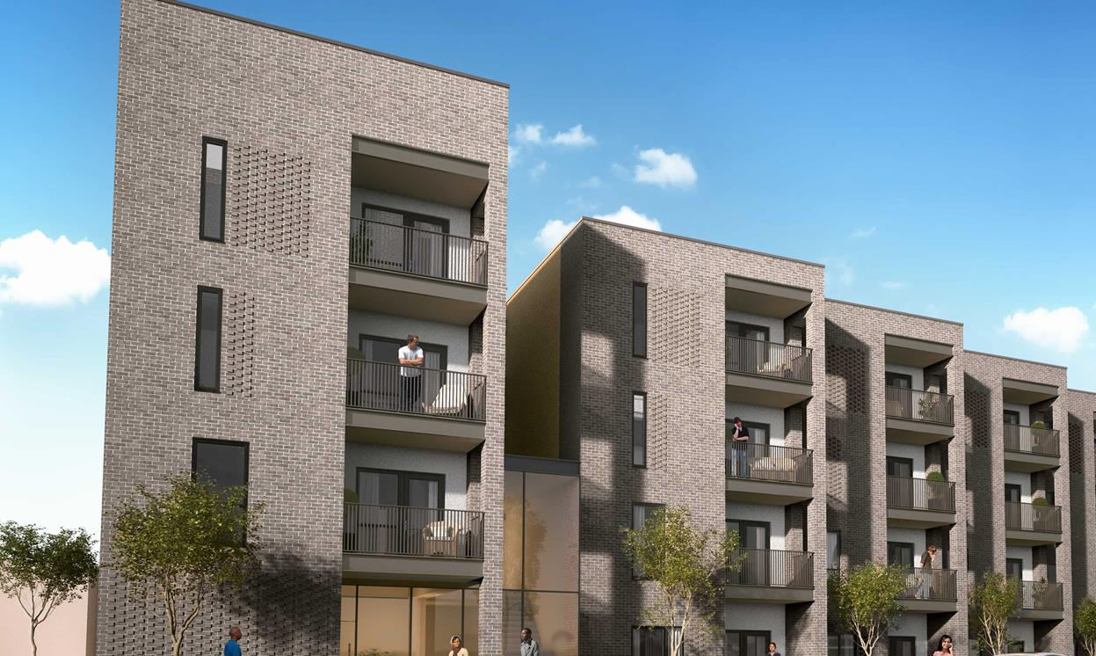
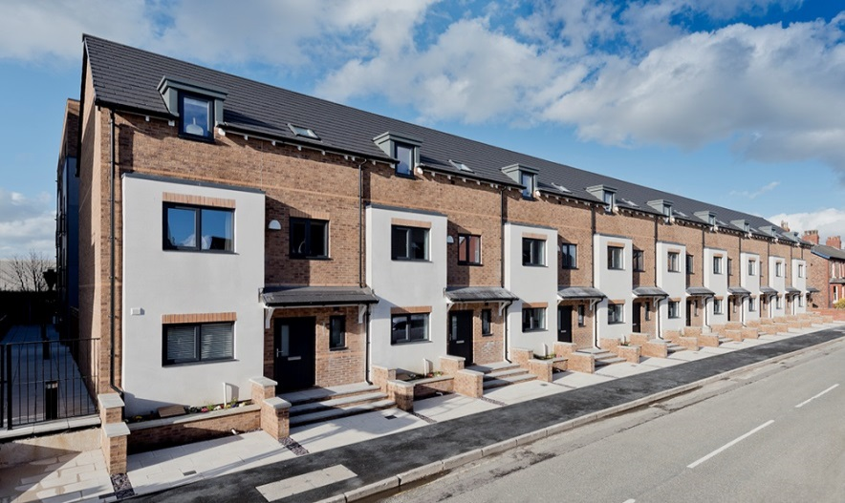

Ref. | Action | By when | By who | Update 2021
ACTION 1: INCREASE HOUSING DELIVERY (MARKET & AFFORDABLE)
1.1 | Develop and introduce a set of community driven Place Plans incorporating town centre, neighbourhood and master plans to help inform and shape the development both the Local Plan and in turn future development itself. | Commence:  January 2019  End - March 2023 | SHP/Strategic Growth Service / residents/Vision 2031 Team/ Place Shaping Board/CCG/NHS | COMPLETED  Housing Propositions from the seven sub areas of Trafford (Carrington & Partington, Sale, Stretford, Old Trafford, Altrincham, Rural Communities and Urmston) have been created and published.
1.2 | Develop a master-plan led approach to appropriate large/strategic sites. | Ongoing | Strategic Growth Service/SHP/ Vision 2031/ Place Shaping Board/CCG/NHS | COMPLETED  Masterplans for sites in Old Trafford, Carrington and Stretford are in place and work is underway with partners such as THT in Old Trafford and Himor in Carrington to bring forward the large sites identified.  Sale West Masterplan being developed by Irwell Valley Homes to address sites within their estate. Village Plans have been developed for Sale Moor and Hale.
1.3 | Partner with the private sector (including Registered Providers) to deliver new homes. | Ongoing | Strategic Growth Service/ SHP/Place Shaping Board/ Amey | The Council has funded 30 social rent apartments in Timperley from the Trafford Affordable Housing Fund and completed in December 2022.
1.4 | Identify, utilise and deploy Council assets (land and buildings) to bring forward more sites for residential development. | Ongoing | Strategic Growth Service/ Place Shaping Board/ Amey/CCG/NHS | A review of Council Land and Assets is underway. At the Increase Housing Delivery Task & Finish Group, the estates team report quarterly on those sites that are available at going to the market, so that the partners are aware.  A further assessment of the smaller sites is underway to determine whether any can be used for custom/self-build and/or modular housing.  The Council’s Development Team in partnership with Seddon’s and Trafford Housing Trust have submitted a planning application for 86 new homes on the site of the former Sale Magistrates Court.
1.5 | Utilise and deploy our CPO powers to acquire strategically significant sites / assets and bring them forward for development. | Ongoing | Place Shaping Board/ Development Management/Amey/ CCG/NHS | Work is still to be undertaken into the potential use of CPO powers to acquire strategically significant sites.
1.6 | Proactively identify, negotiate and where appropriate acquire sites to speed up development. | Ongoing | Strategic Growth Service/ Place Shaping Board/ Amey/CCG/NHS | Trafford Council has established a development team who are leading on acquiring sites for development and/or investment. Acquisition of Stretford Mall, Grafton Centre and Sale Magistrates has already taken place.
1.7 | Where appropriate package sites to deliver more housing / improved mix / improved viability. | Ongoing | Strategic Growth Service/SHP/ Place Shaping Board/ Amey/CCG/NHS | Trafford Council is working with Trafford Housing Trust on the development of the Tamworth area in old Trafford which has involved a Joint Venture approach with the packaging of sites from THT and the Council together.
1.8 | Research and explore opportunities to deliver more self and customer build properties. | Ongoing | Strategic Growth Service/Amey/Place Shaping Board | A Self Build review is taking place and the Council is working with the Estates Team to look at identifying possible sites that can be granted planning permission for custom/self-build.  Work is underway in Strategic Planning regarding the Council’s obligations as contained within the Self & Custom Build Act. Appropriate sites are being identified and will then be offered to those applicants on the Self-Build Register to purchase.
1.9 | Research and explore opportunities to deliver accommodation through non-traditional methods of construction. | Ongoing | Strategic Growth Service/Development Management/ Amey/SHP | Officers within the Housing Strategy & Growth Team have visited a number of modular house building factories and are encouraging RPs to develop modular housing as part of schemes. In addition, a representative from Ilke Homes regularly attends the Increase Housing Delivery Task & Finish group.
1.10 | Work with investors to deliver more bespoke build to rent accommodation. | Ongoing | Strategic Growth Service/ Place Shaping Board/ Amey | Work is ongoing to develop relationships with investors to increase the provision of bespoke build to rent accommodation.
1.11 | Regularly review and up-date our evidence base to accurately inform the appropriate mix, type and location for affordable housing –Housing Need & Demand Assessment. | By January 2020  Review every 3 years. | Strategic Growth Service | Housing Need and Demand Assessment commissioned, and final report received in January 2020 which will provide up to date evidence on the type, size and tenure requirements for each of the sub areas in Trafford.
1.12 | Research and explore the potential in Trafford for Community Land Trusts. | March 2020 | Strategic Growth Service/ Place Shaping Board/ Amey | Community Land Trusts provide great benefits to communities. However, there are not any Trust opportunities within Trafford currently.  Discussions with the National Trust in relation to creating a Community Land Trust in Trafford have taken place, however this was a pre-Covid conversation that needs to be picked back up.
1.13 | Introduce and extend the type and range of affordable housing products to meet all housing needs. | Ongoing | Strategic Growth Service/SHP | COMPLETED  Housing Need and Demand Assessment commissioned, and final report received January 2020 which provides up to date evidence on the type, size and tenure requirements for each of the sub areas in Trafford in particular affordable housing need.
1.14 | Research and develop new financial products and support to help local people access homes to rent and buy. | Ongoing | Strategic Growth Service /SHP/ Finance | Research is still to being undertaken into the potential development of new financial products to support local people in accessing homes to rent and buy.
1.15 | Establish a Trafford Housing Fund to provide additional financial support for housing priorities as identified through the housing propositions. | January 2020 | Strategic Growth Service / Finance | COMPLETED  Trafford Affordable Housing Fund established in September 2018. The Fund combines all affordable housing planning contributions made via a S106.  A bid has been received from THT to provide 30 social rent apartments in Altrincham which has been approved. This bid removes all monies currently in the fund, however this will be replenished when further affordable housing commuted sums via S106 are received.
1.16 | Consider local assets in the identification of any new developments and possible impacts on service capacity and demand such as General Practice. | Ongoing | CCG/NHS/Strategic Growth Service/ Planning/Place Shaping Board/ Amey | Work still to be undertaken.
ACTION 2: REBALANCE THE HOUSING OFFER ACROSS TRAFFORD

2.1 | Undertake a Housing Need and Demand Assessment (HN&DA) for Trafford. | By December 2018 | Strategic Growth Service | COMPLETED  The Housing Need and Demand Assessment has been commissioned and the final report will be available in August 2019.
2.2 | Develop a set of ‘Housing Propositions’ for each of Trafford’s places and communities. | Commence  January 2019  End - March 2023 | SHP/Strategic Growth Service / residents/Vision 2031 Team/ Amey/Place Shaping Board/CCG/NHS | COMPLETED  Housing Propositions for the seven sub areas of Trafford (Carrington & Partington, Sale, Stretford, Old Trafford, Altrincham, Rural Communities and Urmston) have been created and published.
2.3 | Regularly review our evidence base and through this establish the appropriate number, level and type of new homes needed in each of Trafford’s places in order to rebalance the market - Housing Need & Demand Assessment. | By December 2018  Review every 3 years. | Strategic Growth Service | Intention is to review the data and evidence by undertaking a Housing Need and Demand Assessment every 3 years. Next commission to commence January 2023.
2.4 | Provide guidance on the appropriate housing densities in relation to their proximity to services (including health) and key transport hubs – linked to creation of the ‘Housing Propositions’. | Commence -  January 2019  End - March 2023 | SHP/Strategic Growth Service / residents/Vision 2031 Team/ CCG/ NHS/Amey/Place Shaping Board/GMCA | Housing Propositions from the seven sub areas of Trafford (Carrington & Partington, Sale, Stretford, Old Trafford, Altrincham, Rural Communities and Urmston) have been created and published. Densities will be confirmed via the development of the draft Local Plan for Trafford.
2.5 | Support the increase and improvement of connectivity (particularly transport links and health) within and across the borough. | Ongoing | Strategic Growth Team/Amey/TfGM/CCG/NHS | Increase Housing Delivery Task & Finish Group established to drive forward the delivery of housing in Trafford. Membership includes Health (NHS/CCG), Highways England, TfGM, Developers, Land Owners, Registered Providers, Education and Planning.  The Trafford Local Plan with is currently in draft and the Places for Everyone GM Plan will include connectivity issues such as transport and health needs.
2.6 | Identify and target sources of external and match funding including maximising receipts from planning obligations. | Ongoing | Strategic Growth Service/Development Management | Work still to commence on this action.
ACTION 3: ADDRESS AND MEET THE HOUSING NEEDS OF OLDER PEOPLE

3.1 | Consult with older residents to establish their housing, support and future care needs - linked to the development of the Older People’s Housing Strategy. | Commence -  October 2018 | Strategic Growth Service/SHP/CFW /CCG/NHS | COMPLETED  Consultation with older residents has been undertaken to determine current and future housing need. The consultation results have fed into the production of the Older Person’s Housing Strategy.
3.2 | Develop an Older People’s Accommodation Strategy. | Commence -  October 2018  End - December 2019 | Strategic Growth Service/SHP/CFW/CCG/NHS | COMPLETED  Strategy developed and launched March 2020.
3.3 | Increase the accommodation options and choices for Older People including where justified / required extra care, life-time homes and suitable / accessible general market housing. | Ongoing | Strategic Growth Service/SHP/CFW/ Planning | Older People’s Housing Task & Finish group established to drive forward the delivery for the Older People’s Housing Strategy.  Trafford Council have purchased two car homes to prevent the closure and avoid the relation of a number of vulnerable residents.
3.4 | Explore options and support requirements for frail older people who want to stay in their own homes. | Ongoing | Strategic Growth Service/SHP/CFW/CCG/NHS | Older People’s Housing Task & Finish group established to drive forward the delivery for the Older People’s Housing Strategy.
3.5 | Explore options to increase social connectivity to support the housing needs of older people including health and wellbeing. | Ongoing | Strategic Growth Service/SHP/CFW/CCG/NHS | Older People’s Housing Task & Finish group established to drive forward the delivery for the Older People’s Housing Strategy.
3.6 | Research and introduce a range of financial products and incentives to enable Older People to continue living in their own home or move to a more suitable dwelling - linked to the Older People’s Housing Strategy. | Ongoing | Strategic Growth Service/SHP/CFW | Older People’s Housing Task & Finish group established to drive forward the delivery for the Older People’s Housing Strategy.
3.7 | Explore options and support requirements for ‘co-housing’ - linked to the Older People’s Housing Strategy. | Ongoing | Strategic Growth Service/SHP/CFW | The Housing Need and Demand Assessment asked residents regarding co-housing. 1,528 households in Trafford stated they would consider co-housing as an option. Further work on this housing option is an action within the Older People’s Housing Strategy 2020-2025.
3.8 | Explore options and support requirements for ‘Homeshare’ - linked to the Older People’s Housing Strategy. | Ongoing | Strategic Growth Service/SHP/CFW | Older People’s Housing Task & Finish group established to drive forward the delivery for the Older People’s Housing Strategy.
ACTION 4: DEVELOP A PLANNED AND QUALITY HOUSING OFFER FOR STUDENTS (CURRENT & FUTURE)

4.1 | Complete the master-planning exercise for ‘UA92’. | Civic Quarter area Masterplan by March 2019  by December 2018  by Summer 2018 | Strategic Growth Service/Place Shaping Board  Stretford Mall/Development Management  Strategic Growth Service/Amey/Place Shaping Board | COMPLETED  A Civic Quarter Plan is being prepared which will set the type and amount of development in the area from Stretford Leisure Centre to Trafford Bar Metrolink Station.  The planning permission for the development of Stretford Mall was exercised with the completion of a reduced footprint in spring 2019.  Lacy Street is scheduled as part of the revised Stretford Masterplan which is due for further public engagement 2019.
4.2 | Develop a Place Plan and Housing Propositions for Stretford and its surrounding areas. | March 2020 | Strategic Growth Service/SHP/ residents/Vision 2031 Team/ Amey/Place Shaping Board | COMPLETED  Housing Propositions for the seven sub areas of Trafford (Carrington & Partington, Sale, Stretford, Old Trafford, Altrincham, Rural Communities and Urmston) have been created and published.
4.3 | Explore the impact of an increased student population in Stretford, Old Trafford and beyond. | Ongoing | Strategic Growth Service/SHP/ residents/Vision 2031 Team/ Amey/CCG/ Place Shaping Board | COMPLETED  A UA92 Welfare Workstream has been established and has taken the format of quarterly meetings and most recently a workshop including a number of stakeholders including CCG, CFW, GMP and GMFRS to under the immediate and potential needs of the Student population (circa 300 2019 intake).
4.4 | Support the appropriate development of new bespoke student accommodation and health provision. | Ongoing | Strategic Growth Service/SHP/ residents/Vision 2031 Team/ Amey /CCG/ Place Shaping Board | COMPLETED  Trafford Council are working with the developer Beech Properties to provide bespoke Student Accommodation for the year 1 intake, which will be at the former Warwick House on Warwick Road opposite UA92.
4.5 | Continue to work with local landlords within the Private Rented Sector to improve standards. | Ongoing | Housing Standards/Development Management/Enforcement/ Building Control | In 2020/21 there were 580 private sector housing service requests received, of which 47 were in Stretford. During 2020/21 there were 27 enforcement notices served across Trafford.  HMO applications continue to be monitored and there has been 30 new applications in 2020/21, including renewal applications.
ACTION 5: IMPROVE EXISITING HOMES
5.1 | Undertake a stock condition survey to establish an up-to-date picture of the condition and quality of homes within the borough and assess any impacts upon health. | By March 2019 | Strategic Growth Service/Housing Standards | COMPLETED  Private Sector Stock Condition completed June 2019.
5.2 | From the results of the stock condition survey, develop a plan and targeted approach to tackle those homes and areas with poor housing. | Ongoing | Strategic Growth Service/SHP/Housing Standards | Private Sector Stock Condition Survey results presented in June 2019. Private Sector Task and Finish Group established and the first meeting will take place in September. The group’s focus will be the development of the area based plan to address property conditions and energy efficiency in the private sector.
5.3 | Establish a multidisciplinary approach to both identifying and addressing problems in the private sector. | Ongoing | Housing Standards/ HOST/SHP/GMP/ Community safety | COMPLETED  Private Sector Task and Finish Group established, and the first meeting will take place in September.
5.4 | Deploy our statutory and non-statutory powers to address poor standards and conditions in line with our evidence base. | Ongoing | Housing Standards/Development Management/ Enforcement/ Building Control | Private Sector Stock Condition Survey results presented in June 2019. Private Sector Task and Finish Group established, and the first meeting will take place in September. The group will be tasked with look at using statutory powers to address poor standards.
5.5 | Improve liaison and links with private landlords through the establishment of a Private Landlords Forum. | March 2020 | Strategic Growth Service/Housing Standards | COMPLETED  Links with private landlords in Trafford has improved during 2018/19. Private Landlords Forum established with two events held in 2019/20.
5.6 | Explore and as appropriate introduce a Landlord Accreditation Scheme with a particular emphasis upon those properties and landlords in and around the new university. | March 2021 | Housing Standards | Trafford Council is working in partnership with the National Landlords Association (NLA). The NLA attend forum events and have providing information on accredited courses they can offer to landlords.
5.7 | Develop a new Empty Property Strategy and action plan. | Commence -  May 2019  End – December 2019 | Strategic Growth Service/Housing Standards | COMPLETED  Empty Homes Strategy developed and launched November 2019.
5.8 | Explore affective and cost efficient ways and mechanisms of bringing empty properties back into use (including EDMOs / enforced sales / acquisition / assistance) – linked to Empty Property Strategy. | Commence -  January 2020 | SHP/Strategic Growth Service/Housing Standards | Empty Properties Strategy now in place and matrix to determine priority of empty properties developed. Housing Standards Team pro-actively working to identify empty homes and ways in which to bring back into use.
ACTION 6: PROVIDE SUPPORT FOR THE PEOPLE WHO NEED IT

6.1 | Work with and at the GM level to support the GM Homeless Action Network. | Ongoing | Strategic Growth Service / HOST/GMCA | Trafford continue to support GM and attend the GM Homeless Action Network.
6.2 | Review and assess the likely impact of the Homelessness Reduction Act upon the Council’s resources. | March 2019 | Strategic Growth Service / HOST | COMPLETED  HRA impact was reviewed, and additional resources were given to HOST to increase the staffing in 2018/19 and 2019/20.
6.3 | Implement a new GM ICT caseload system for homelessness. | December 2018 | Strategic Growth Service / HOST | COMPLETED  New ICT system in place across GM to manage the HRA and homelessness case work.
6.4 | Revise Trafford’s Homelessness Strategy | December 2018 | Strategic Growth Service / HOST/Homeless Champions Group/SHP/CCG/NHS | COMPLETED  Trafford Homelessness Strategy reviewed, and new Strategy launched March 2019. Homeless Champions Group leading on the delivery of the Action Plan and a number of Task & Finish Groups has been established to drive forward delivery.
6.5 | Develop a Supported Housing Strategy. | March 2021 | Strategic Growth Service / SHP/CFW/CCG/NHS | Draft Supported Housing Strategy production underway. Working in partnership with Adult Services Commissioning Team. Draft Strategy will be going out for consultation early Summer 2022.
6.6 | Explore opportunities to extend and increase the provision of temporary accommodation. | Ongoing | Strategic Growth Service / HOST / SHP/RPs | HOST proactively work to increase the provision of temporary accommodation in Trafford to try and eradicate the use of B&B.  As of 31st March 2021, there were 5 in B&B.  In 19/20 we placed 29 families at an average of 14.06 nights.  In 20/21 we placed 21 families at an average stay of 9.3 nights.
6.7 | Work proactively with private sector landlords to secure more accommodation for homeless households, including the use of incentives, bonds, enhanced tenant support and advice. | Ongoing | Strategic Growth Service / HOST/Housing Standards/RPs | HOST have a dedicated Officer who works with private landlords and manages the Rental Bond Scheme. HOST has been networking with current landlords and encouraging them to introduce HOST to other landlords in Trafford to increase access to accommodation in the sector. HOST assisted 134 customers in 2019/20 with help towards a bond and rent in advance or the extension of a current bond. 59 were assisted with a bond,  67 were assisted with rent in advance and 8 bonds were renewed.
6.8 | Ensure access to and awareness of local services Through the Trafford Service Directory | March 2019 | Family Information Service/CCG/NHS | COMPLETED  Trafford Service Directory publicised by HOST.
6.9 | Agree and establish targets for apprenticeships in construction for local people. | Ongoing | Social Value Group/Procurement/ Strategic Growth Service | The Council are starting to coordinate what this will look like and have a meeting with all construction projects in Partington and Carrington in August to build up a picture of how many apprenticeships and job opportunities will be coming online in the area over the next 12 months.
6.10 | Develop pathways into construction jobs and apprenticeships for local people. | Ongoing | Construction Sub-Group/Inclusive Growth Board/SHP | The Construction sub-group have agreed to coordinate all upcoming opportunities through Procure Plus who have Construction Industry Training Board (CITB) funding to create local training hubs in areas where there are a number of projects.
6.11 | Support homeless people and those in insecure tenancies into employment and training opportunities. | Ongoing | TEES/Inclusive Growth Board/SHP | Homeless people are supported through the Trafford Pledge but we don’t currently have a mechanism for identifying clients in insecure tenancies. A new Employment, Education & Training Task & Finish Group will convene in September and will look at the issues surrounding this.

https://assets.publishing.service.gov.uk/government/uploads/system/uploads/attachment_data/file/733421/Rough-Sleeping-Strategy_WEB.pdf
https://www.legislation.gov.uk/ukpga/2021/17/contents/enacted
https://www.gov.uk/guidance/homelessness-code-of-guidance-for-local-authorities
gmhs-implementation-plan_june-2021.pdf (greatermanchester-ca.gov.uk)
Homelessness Prevention Strategy - Consultation Draft (greatermanchester-ca.gov.uk)
gm-homelessness-prevention-action-plan.pdf (gmhan.net)
Trafford Council Corporate Plan 2021-24
http://www.trafford.gov.uk/about-your-council/strategies-plans-and-policies/housing-strategy/docs/Trafford-Council-Empty-Homes-Strategy-2019-2024.pdf
http://www.trafford.gov.uk/about-your-council/strategies-plans-and-policies/housing-strategy/docs/Trafford-Older-Peoples-Housing-Strategy-2020-2035.pdf
http://www.traffordpartnership.org/locality-working/Docs/Trafford-Together-Locality-Plan.pdf
Domestic Abuse Strategy 2021.pdf (trafford.gov.uk)

