

**TRAFFORD COUNCIL DIRECT PAYMENT – PAYMENT PROCESS**

A Direct Payment Broker will complete an Initial Review during which all aspects and responsibilities of managing Direct Payment Funding will be discussed. If you or your nominated Suitable Person decide Direct Payment Funding is the most suitable method to fund your chosen care provision, we will make an agreement for your services to be funded via a Direct Payment.

**Responsibilities of TRAFFORD BC Direct Payment Audit Team**

Details of your Direct Payment will be provided to the Direct Payment Audit Team. They have the following responsibilities:

* Confirming your Direct Payment Funding has been set-up and you are active within Trafford Council’s payment system
* Ordering and setting up of a Prepaid Financial Services (PFS/EML) pre-payment card account (if required)
* Ensuring payments are made every 4 weeks, in accordance with the funding schedule
* Ensuring any authorised one-off payments are made upon request
* Auditing your Direct Payment account on a 3, 6 or 12 monthly basis (to confirm the funding is being used in line with your care plan and highlighting any possible concerns)

**Direct payment account type**

Your Direct Payment funding is paid into a dedicated bank account. There are several types of account:

* Self-Managed Account with a high street bank - the bank account must be separate from your personal monies and be for the sole use of the Direct Payment.
* A prepayment card account - this is with the prepayment card provider used by Trafford Council, Prepaid Financial Services (PFS/EML). The Direct Payment Audit Team have online access to these accounts.
* Accountant Administrated - an accountant holds the funding on the your behalf. However, the actual management of the account is retained by you or your nominated ‘suitable person’ (see below).
* Fully Managed Account – this type of account is usually used where a client lacks capacity to manage their funding or the management of their care themselves or does not have a trusted person who they could nominate as their “Direct Payment Suitable Person”. (see below for details of Suitable Person Responsibilities)

When the Direct Payment is being set up by your Direct Payment Broker, the options regarding the account type will be discussed with you to ascertain the best option for you.

**Prepayment card account**

If you choose a prepayment card, we will give you help on how to operate the account online.

There is also a dedicated telephone line with the card provider. Arrangements can be made for invoices to be paid on your behalf.

It is beneficial if you choose to use either a Self-Managed High Street Bank Account or a PFS Pre-payment Card Account, to operate the account via on-line banking via a laptop or tablet/iPad, (you may not be able access all areas of the account using a mobile phone). This will simplify making payments to care providers from the account and also making payments of community care client contribution charges into the account (if applicable).

**Direct Payment Suitable Person**

The majority of Direct Payment recipients will nominate someone to act as ‘suitable person’ on their account. The suitable person manages the account on your behalf. This person may already act as your financial appointee (managing your personal finances, DWP Benefits), for example, but it does not have to be the same person. Often, the suitable person is a family member or close friend.

It is important to note that your suitable person is responsible for the management of your Direct Payment account. This includes providing audit information, paying invoices, organising care provision, and so on.

**Direct payment funding – payments**

**Pay Calculation**

Once the agreement to receive a Direct Payment has been made, we will give you a Pay Calculation. The pay calculation is based on the Assessment of Need and care plan, identified by a Social Worker or Social Care Assessor.

This calculation shows the ‘Gross’ total weekly amount of funding required to cover your assessed need. It gives a breakdown of the cost of each service, number of hours, and hourly rate for services required to provide outcomes to the assessed need. It also includes any additional costs required when employing a personal assistant.

Trafford Council pays the ‘Net’ figure, which is minus any community care client contribution to be paid (see ‘Community Care Client Contributions’ below).

Funding can be used flexibly in line with the assessed need, but should be kept within the Gross weekly amount shown on your pay calculation. A short care plan can also be developed with the Direct Payment Brokerage Team to confirm how the funding provided can be spent to gain the desired outcomes that support is to provide.

**Top-up payments**

Some care providers charge above the Trafford Council funding rates (detailed on the pay calculation). If this happens, a top-up payment will need to be made by yourself into the Direct Payment Account to cover the additional cost. Trafford Council Direct Payment Audit Team can assist with the calculation of any Top-up payment if required.

This payment should be made from your personal funds and be paid directly into the Direct Payment account. It is separate from any community care client contribution payment, so they need to be paid as a separate amount so they are easily identifiable by the Audit team when completing regular audits of the account.

**Use of funding**

Funding should be kept within the weekly budget and be related to your care needs.

If there are any changes to your care needs, such as a deterioration of your health, a review of the case should be requested via your Social Care Team. This is also the same for any additional care/expenditure that is not included within the care plan.

Any funds used for items not shown on your Pay Calculation or Care Plan and therefore authorised by your Trafford Council Social Care Team may be classed as ‘misspent funds’. The Direct Payment Audit Team will request these be repaid to Trafford Council

**4-weekly payment cycle**

Payments from Trafford Council for Direct Payment funding are made on a 4 weekly cycle. Direct Payment Funding is paid in advance, i.e. payments made at the beginning of the period cover the following 4 weeks.

When payments begin an interim payment may be made. This interim payment will be made from the Direct Payment funding start date up to the end of the 4 week period in which the payment commenced.

Payments will then be made in line with the usual 4 weekly payment cycle. The Direct Payment Audit Team will give you a copy of an Audit Calendar to advise of payment dates and the periods covered.

When the Direct Payment funding is ended, due to the payments being made in advance, there will be a reclaim of funds. This is from the end date of the Direct Payment to the end of the period the payments have been made up to. The Direct Payment Audit Team will provide notification of the reclaim following the final audit of the account.

**Direct payment funding – community care client contribution payments**

As part of Trafford Council’s provision of care, Trafford Council are required to complete a financial assessment for every applicant of Social Care Funding. This determines a weekly amount the client can afford to pay towards the cost of the social care services provided. The result of this financial assessment is referred to as a ‘Community Care client contribution charge’.

Direct Payment funding is paid ‘Net’ of the community care client contribution charge amount. Therefore, you are required to make arrangements to pay to the community care client contribution charge amount into the same Direct Payment account as the Direct Payment Funding payments you receive from Trafford Council. This will ensure sufficient funds are available in this account to cover the weekly cost of your care plan.

Trafford BC suggest that standing order payments be set up to pay the weekly assessed community care client contribution charge amount from your personal bank account. Trafford Council also advise you to pay the community care client contribution charge every 4 weeks, in line with the Direct Payment 4 weekly payment. A copy of the Audit Calendar will be provided to assist with this set up.

It is advisable that you have access to either online banking or have a telephone banking arrangement with the bank with whom you hold your personal account. This helps ensure required amendments to any such Standing Order payments can be made easily and quickly, as these regular community care client contribution charges may change.

These assessed Community Care Client Contribution charges may change at the start of each financial year, in line with DWP benefit changes (if applicable), or when there are any changes to your personal income or personal financial circumstances. A letter will be sent to you (or your financial appointee if applicable) from Trafford Council Financial Assessment Team advising of any such changes to this charge.

Calculations of any under/overpayments relating to the community care client contribution charges are made when an audit of your Direct Payment account is completed. This ensures the contribution is being paid correctly. A statement of account showing the charges due and the payments made will be provided following completion of the audit if required.

If you have any questions or would like more information about Direct Payments, please contact:-

**Direct Payment Brokerage Team**

Telephone: 0161 912 2701

Email: [directpayments@trafford.gov.uk](mailto:directpayments@trafford.gov.uk)

**Direct Payment Audit Team:**

Telephone: 0161 912 2787

Email: [directpaymentsaudit@trafford.gov.uk](mailto:directpaymentsaudit@trafford.gov.uk)

Or visit the Direct Payment Webpage at:-

<https://www.trafford.gov.uk/residents/adults-and-older-people/Direct-Payments/Direct-Payments.aspx>

**Glossary of Terms:-**

[1] Direct Payment Suitable Person

Direct Payment Suitable Person. A Direct Payment recipient can nominate a ‘Suitable Person’ to act on their behalf to administer the Direct Payment Funding and the care provision identified within their assessment of need.

This person may already act as a financial appointee, with the Department of Work and Pensions or managing personal finances on the recipient’s behalf. The appointed ‘Suitable Person’ is responsible for the management of the Direct Payment Funding, administration of the Direct Payment account, paying invoices, organising care provision etc.

When an audit of the Direct Payment Account is required, they will also be responsible for ensuring all documents, which relate to the requested period of time, are provided to the Direct Payment Audit Team in a timely manner.

A Suitable Person is also responsible for ensuring that all payments of invoices, Personal Assistant payroll payments etc are made from the Direct Payment Account are made in line with the funding provided. Any items of expenditure taken form the Direct Payment Account that are not detailed in the Direct Payment recipients care plan, may be requested to be repaid to Trafford BC.

A Suitable Person is also responsible for ensuring that any community care charge client contribution amounts that are due are paid correctly and compliantly into the Direct Payment Funding account regularly, either via a standing order or bacs transfer.

**4 WEEKLY PAYMENT - AUDIT CALENDAR - example**

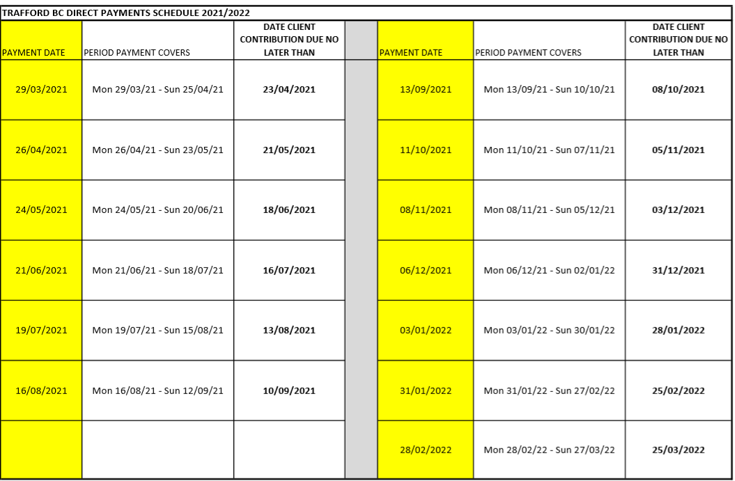

* Payment Date – Date 4 weekly payment will be released, payments are made by BACS so will credit the Direct Payment account 2/3 days after being released
* Period payment covers – 4 weekly period covered by payment – (4 weekly in advance)
* Date Community Care Client Contribution Due – Date payment should be made into the account to ensure sufficient funds are available to pay for the services being purchased using Direct Payment funding