Trafford Economic & Housing Growth Framework

Technical Annex Report

June 2016
Classification of this document: | Company Confidential
Definition | Information which is restricted to specified MGC employees or that is disseminated to other parties as authorised by the Information Owner. Unauthorised access could cause an important financial and/or reputational loss to MGC; provide a significant competitor gain or a drop in customer confidence.
Storage | Paper format - stored in a lockable filing cabinet in secure offices with no public access. Keys to filing cabinets must be stored in a Key Safe.
 | Not left unattended (e.g. table, desk or printer) as per MGC Clear Desk & Clear Screen Policy.
 | On systems – protected by login ID/password, and appropriate access restrictions.
 | Should not be saved directly to desktops, laptops or tablets where this can be avoided. Where this is unavoidable the information should only be stored on a company authorised and encrypted device and should be removed as soon as possible.
 | Critical data must be stored on a secure server that is frequently backed up
 | USB devices - only held on encrypted devices.
 | Premises - must have appropriately controlled access (e.g. restricted access via code locks/reception desks)
Title | Trafford Economic & Housing Growth Framework – Technical Annex
Version | 2.0
Author
Creation date | May 2016
Data sources from which personal data extracted (e.g. database)
Data Parameters (e.g. timeframes)
Primary customer | Trafford Borough Council

Introduction
This ‘Technical Annex’ accompanies the ‘Trafford Economic & Housing Growth Framework Report’ and provides further detail on the Cost Benefit Analysis (CBA) approach which has been used to assess each of the interventions identified within the Framework.
For each of the interventions, this ‘Technical Annex’ provides a:
- Logic model showing the context for the intervention, the required inputs and resources and the anticipated outputs and impacts of the intervention.
- Cost Benefit Analysis (CBA) to show the impact and value for money of each intervention.
Note that Intervention 3: Future Workforce Investment has been included within the CBA analysis as part of Intervention 4: Leveraging Wider Business Support Capacity.
Logic models
The logic models are a visual representation of each intervention, setting out the context for the interventions, and the theory of change linking the inputs and resources going into the project to a resultant impact of the interventions.
In each logic model we have summarised the expected costs of delivering the initiative (inputs), the activities undertaken, and the expected outputs, outcomes and impacts of the programme.
Cost Benefit Analysis (CBA) methodology
For each of the interventions identified in the Framework, we have carried out a CBA to understand the value for money of the interventions outlined. We have used the methodology that has been developed by New Economy and adopted by HM Treasury as supplementary guidance to the Green Book.
For each initiative we have estimated the total costs of delivering the intervention, and then calculated the benefits based on monetising the improved outcomes that result from the interventions (e.g. additional jobs, visitors etc.). The estimation of costs includes any staff costs, which realistically is likely to be staff from existing roles within the Council, rather than new positions.
In order to take account of uncertainty in the estimates, we have applied optimism bias correction to the figures dependent on the strength of the evidence base. This reduces the risk of the analysis overstating the value for money of a programme and gives confidence to the decision makers who are considering commissioning the intervention. Optimism bias for costs and benefits can vary from 0% (for independently audited figures) to 40% (for uncorroborated expert judgements). For example:
- Optimism bias for costs: If a project costs £100,000 but this estimate is based on an uncorroborated expert judgement, the optimism bias is 40% – with costs increasing to £140,000.
- Optimism bias for benefits: If a project aims to create 100 jobs in an area but this view is also based on an uncorroborated expert judgement, optimism bias is 40% – with the jobs estimate being reduced to 60.
All costs in this report include optimism bias.
We have considered two approaches for looking at value for money of the projects. These are:
- The financial case for Trafford Council - this just considers the costs to Trafford of implementing the proposal (e.g. officer time, marketing etc.) and the financial benefits to Trafford (increased Business Rates take, increased Council Tax take). These extra financial benefits could then be reinvested in further economic development provision to sustain and grow the Trafford economy. In terms of Business Rates, details of how the increase in income will be apportioned to Trafford are unclear until future consultation with Government and to discuss pooling arrangements across Greater Manchester.
- The wider public value case created by the intervention – as well as considering the financial impact to Trafford Council due to changes in income and expenditure, it is also important to understand the wider benefits to residents, communities and businesses across Trafford. This is known as public value, and includes the economic and social benefits of increased growth (GVA) to show the wider impact on society. Public value benefits therefore represent a measure of the overall value to society and include:
- All fiscal benefits except transfer payments such as taxation or social security that just move money from one place to another. Real increases in the quality or quantity of output can be included but are not always easy to quantify or monetise.
- Net growth in the local economy allowing for deadweight, leakage and substitution.
- Wider social benefits including gains to society such as improvements to health; educational attainment; access to transport or public services; safety; or reduced crime.
It is important to note that the benefits presented in this section are intended to provide a best estimate view about what might happen under each intervention. Given the high level nature of many of our assumptions, low/medium/high scenarios have not been presented.
We have considered different analysis timeframes for each intervention, dependent on the expected longevity of the benefits. For example for a long term strategy such as the development of Carrington, we have used a 20 year time frame, whereas for medium term initiatives such as the integrated culture, leisure and tourism offer we have used a 5 year time frame.
We have presented the financial figures in two ways.
- The first sets out the outputs and related financial impacts for each of the interventions over the next 5 years. This data is presented in a consistent price base (2015/16), and has not been discounted.
- The second presents the return on investment over the time frame considered for the analysis (see above). For these calculations, we have discounted the costs and benefits in future years using the standard HMT Green Book discount rate of 3.5% per year.

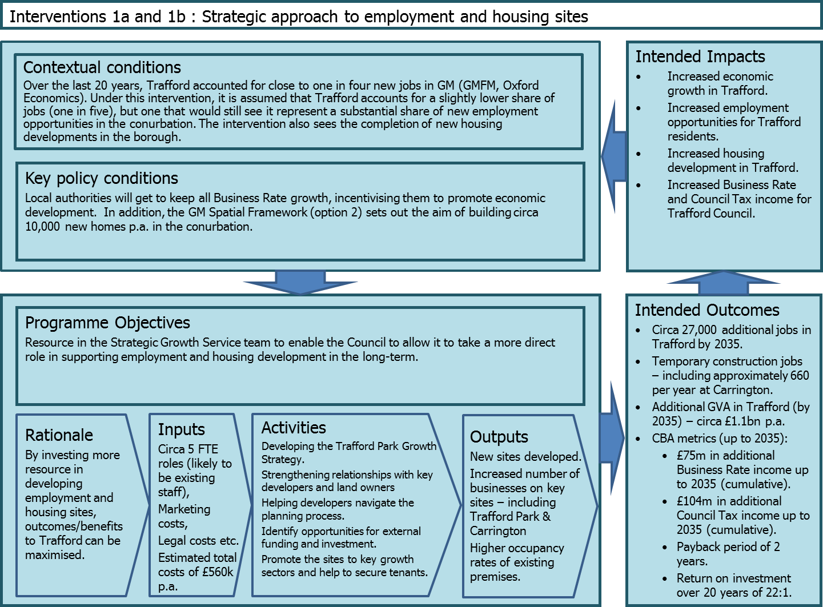
Intervention 1a: Strategic approach to employment sites
CBA Assumptions
Over the last 20 years, Trafford accounted for close to one in four new jobs in GM (GMFM, Oxford Economics). Under this intervention, it is assumed that Trafford accounts for a slightly lower share of jobs over the next 20 years (one in five) but one that would still see it represent a substantial share of new employment opportunities in the conurbation. Staff resource for the intervention is assumed to come from existing officers within the SGS.
Costs are very high level – it is likely that any developers would bear a substantial proportion of these, and costs should be treated as being indicative only. We have estimated them at £280,000 p.a. which would include staff costs associated with marketing, planning, legal fees etc. This includes optimism bias of 40%, which has been added to reflect the fact that our workings are based on estimates and cannot be broken down into further detail.
Benefits to Trafford come in the form of increased jobs (circa 27,000 – net), GVA and business rates up to 2035. For GVA, we have used average GVA per employment in Trafford from the GM Forecasting Model of around £40,000 p.a. and then applied this to the jobs figures for each year of the analysis period.
Outputs
Over the first 5 years of development, the outputs are estimated at:
Output | 2016/17 | 2017/18 | 2018/19 | 2019/20 | 2020/21
Jobs | 900 | 900 | 900 | 900 | 900
GVA | £36m | £36m | £36m | £36m | £36m
Business rates | £0.7m | £0.7m | £0.7m | £0.7m | £0.7m

The overall financial return of the intervention over a 20 year period is estimated at 18:1 by the CBA model – i.e. for every £1 put in, £18 is generated in benefits. The table below presents the discounted costs and benefits:

Financial Case
20 year time horizon | Trafford Fiscal Costs & Benefits
Costs | £4.2m
Benefits (Business rates) | £75m
Return on investment | 17.75

Public Value Case
20 year time horizon | Public Value
Costs | £4.2m
Benefits (GVA) | £4.0bn
Return on investment | 954.23

Intervention 1b: Strategic approach to housing sites
CBA Assumptions
Under intervention 1b, it is assumed that Trafford achieves housing growth as outlined in the GM Spatial Framework (option 2) of 1,006 per annum over a 10 year period.
Under baseline conditions, it is assumed that Trafford grows in line with the most recent GMFM forecasts, which are “policy off” – i.e. the Borough’s economy grows in line with recent trends, with no account made for any future interventions which may boost growth.
Costs are very high level – it is likely that any developers would bear a substantial proportion of these, and costs should be treated as being indicative only. We have estimated them at £280,000 p.a. which would include staff costs associated with marketing, planning, legal fees etc. This includes optimism bias of 40%, which has been added to reflect the fact that our workings are based on estimates and cannot be broken down into further detail.
Benefits to Trafford come in the form of increased Council Tax, up to 2035. We have used the current rate for Band D in Trafford of £1,315 p.a. to calculate increased Council Tax receipts. The Council would also receive the New Homes Bonus as a result of the new properties built in the borough. The estimated amount of New Homes Bonus per home per year is £1,200 based on current arrangements and information provided by the Council.

Outputs
Over the first 5 years of development, the outputs are estimated at:
Output | 2016/17 | 2017/18 | 2018/19 | 2019/20 | 2020/21
Council Tax | £1.3m | £1.3m | £1.3m | £1.3m | £1.3m
New Homes Bonus | £1.2m | £2.4m | £3.6m | £4.8m | £6.0m

The overall financial return of the intervention over a 20 year period is estimated at 25:1 by the CBA model – i.e. for every £1 put in, £25 is generated in benefits. The New Homes Bonus has not been included in the CBA analysis, on the basis that it is unclear how long it will be in place for. The table below presents the discounted fiscal costs and benefits. Although the intervention will also have public value impact, we are not able to quantify this impact in this case, and therefore only the fiscal case is presented below.

20 year time horizon | Trafford Fiscal Costs & Benefits
Costs | £4.2m
Council Tax Take | £104m
Return on investment | 24.68

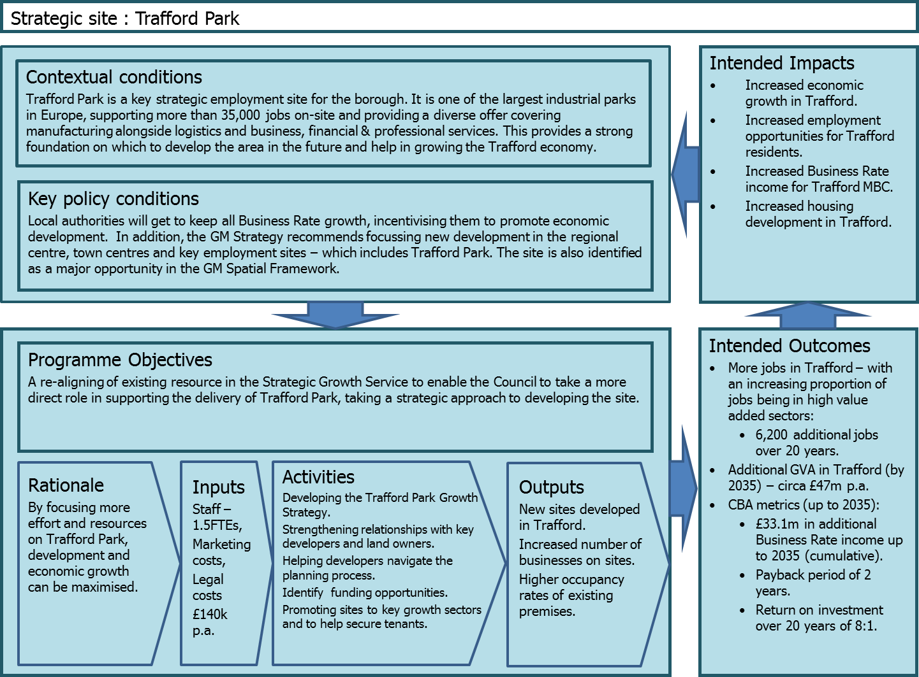

Strategic Site: Trafford Park
CBA Assumptions
Employment in the Trafford Park area is currently around 37,800 – based on 2014 data from the Business Register & Employment Survey. Employment in Trafford Park grew by 0.5% per annum between 2011 and 2014, below total employment growth in Trafford (2.4% p.a.) and GM (1.4% p.a.).
Under baseline conditions (i.e. no intervention from the Council) it is assumed that Trafford Park’s employment will continue to grow at the same annual rate as it did between 2011 and 2014 i.e. 0.5%. By 2035, this would lead to 4,100 additional jobs.
Under the intervention option (greater strategic input from the Council), it is assumed that Trafford Park’s employment will grow by 1.0% p.a each year up to 2035 – which would bring it more in line with recent growth rates in GM and Great Britain. By 2035, this would lead to 8,400 additional jobs, or 4,400 jobs when the baseline growth figure (4,000) is taken into account.
Currently, around 26% of jobs in Trafford Park are in “high value added” roles – which is taken to include the sectors of: Manufacturing; Information & Communication; Financial & Insurance; Property; and Professional, Scientific & Technical activities". For Trafford as a whole, the figure is just over 30%. It is assumed that under the intervention, one third of new jobs will be in these higher value added sectors.
In terms of indicative costs, it is assumed that there is 1 full time equivalent (FTE) for Trafford Park and 0.5 FTE management time, along with marketing and any legal fees that may be incurred. These have initially been estimated at £140,000 p.a. – which includes allowance for optimism bias (set at 40%, which is the highest option available and takes into account that our workings are based on estimates) .
In terms of benefits, using data on business rates for GM, it is possible to convert the GVA figures outlined above for Trafford Park into an estimate of additional business rate income for Trafford Council as a result of the new jobs created.
Outputs
Over the first 5 years outputs are estimated at:
Output | 2016/17 | 2017/18 | 2018/19 | 2019/20 | 2020/21
Jobs | 190 | 190 | 200 | 200 | 200
GVA | £13.1m | £13.2m | £13.4m | £13.6m | £13.8m
Business rates | £0.24m | £0.25m | £0.25m | £0.25m | £0.26m

It is noted that the outputs from Trafford Park shown above form a portion of ‘1a) Strategic approach to employment sites’.
The cumulative additional Business Rates in Trafford from 2014/15 to 2034/35 are estimated at £17m – which takes into account optimism bias (assumed to be the highest rate possible at 40% because of the high level assumptions made).
The overall financial return of the intervention over a 20 year period is estimated at 8:1 by the CBA model – i.e. for every £1 put in, £8 is generated in benefits. The table below presents the discounted costs and benefits:
Financial Case
20 year time horizon | Trafford Fiscal Costs & Benefits
Costs | £2.1m
Benefits (Business rates) | £17.0m
Return on investment | 8

Public Value Case
20 year time horizon | Public Value
Costs | £2.1m
Benefits (GVA) | £916m
Return on investment | 440

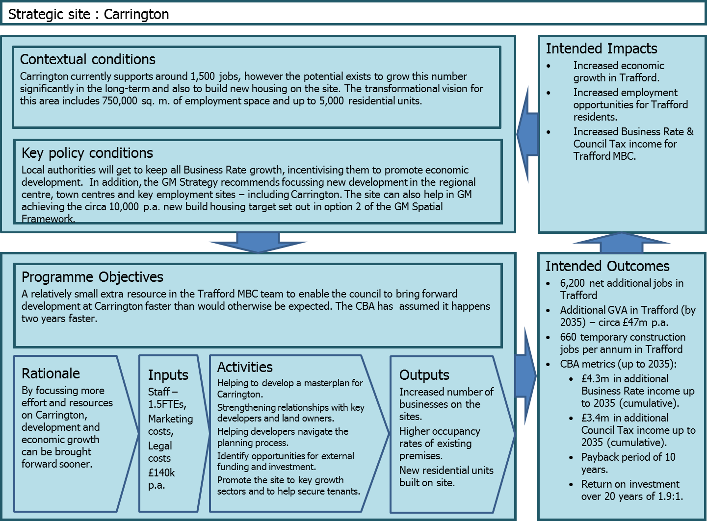
Strategic Site: Carrington
CBA Assumptions
Total size of site is 750,000 sq. m, based on information provided by Trafford Council. As a starting point, floorspace has been split as follows: 10% B1c; 30% B2 and 60% B8.
Standard employment densities have been applied depending on floorspace type, with leakage, deadweight, displacement and multiplier effects then being factored in to arrive at a net jobs figure. This comes out as 6,900 additional jobs in Trafford once the site is fully developed and occupied.
Up to 5,000 homes could be built on the site up to 2035 – this has been factored into the analysis based on a slow start of development increasing over time up until 2035. Council Tax receipts are the main benefit to the Council – the current rate for people in Band D in Trafford is £1,315 p.a. and this has been used to calculate the uplift for the area as a result of new homes being built. The Council would also receive the New Homes Bonus as a result of the new properties built in the borough. Based on information provided by the Council, the bonus amounts to £1,200 per home per year.
In terms of costs it is assumed that there are 1.5 FTEs for Carrington, along with marketing and legal fees. These have initially been estimated at £140,000 p.a. – which includes allowance for optimism bias (set at 40%, which is the highest option available and takes into account that our workings are based on estimates). It is likely that any developers would bear a substantial proportion of these, and costs should be treated as being indicative only. It has been assumed that the benefits delivered by Carrington in terms of GVA, business rates and Council Tax would happen anyway, but via Council support they are accelerated – happening faster than would otherwise be expected. It is this benefit that has been analysed using the CBA model.
Using data on business rates for GM it is possible to convert the GVA figures outlined above for Carrington into an estimate of additional business rate income for Trafford Council as a result of the new jobs created.
Outputs
Over the first five years the additional outputs associated with accelerating the development of Carrington are estimated at:
Output | 2016/17 | 2017/18 | 2018/19 | 2019/20 | 2020/21
Jobs | - | - | 100 | 190 | 290
GVA | - | - | £4.6m | £9.3m | £13.9m
Business rates | - | - | £0.09m | £0.17m | £0.26m
Council Tax | - | - | £0.03m | £0.07m | £0.10m
New Homes Bonus | - | - | £0.06m | £0.06m | £0.09m
It is noted that the outputs from Carrington shown above form a portion ‘1a) Strategic approach to employment sites and 1b) Strategic approach to housing.
The cumulative additional business rates and Council Tax receipts in Trafford from 2014/15 to 2034/35 are estimated at £7.7m – which takes into account optimism bias (assumed to be the highest rate possible at 40% because of the high level assumptions we have made).
The overall financial return of the intervention over a 20 year period is estimated at 1.9:1 by the CBA model – i.e. for every £1 put in, £1.90 is generated in benefits. The New Homes Bonus has not been included in the CBA analysis, on the basis that it is unclear how long it will be in place for. The table below presents the discounted costs and benefits:
Financial Case
20 year time horizon | Trafford Fiscal Costs & Benefits
Costs | £4.1m
Benefits | £7.7m
Business rates | £4.3m
Council Tax | £3.4m
Return on investment | 1.9

Public Value Case
20 year time horizon | Public Value
Costs | £4.1m
Benefits (GVA) | £231m
Return on investment | 57

In addition to the outputs described above, estimates have been produced of the number of construction jobs that could be created by developing Carrington. Produced by Regeneris, they indicate that around 660 construction jobs could be created on an annual basis over a 20 year period.

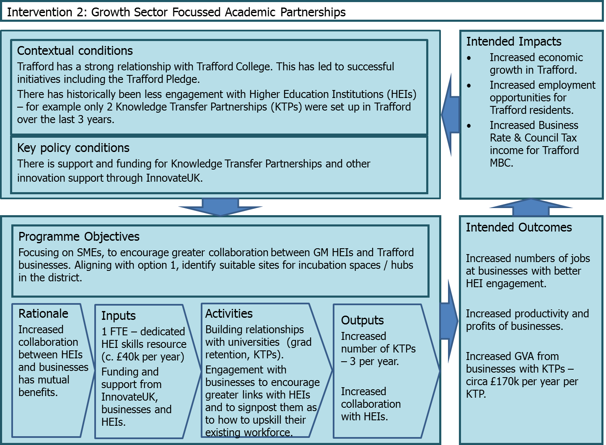
Intervention 2: Growth Sector Focused Academic Partnerships
CBA Assumptions
It is assumed that under this initiative, a new dedicated HEI skills resource is created (1 FTE). Their role would be to
- develop relationships with universities focussed on growing engagement in sector strengths (graduate retention, KTPs). This would cover half an FTE.
- engage with businesses to support them to build relationships with universities and to signpost them as to how to upskill their existing workforce. This would also cover half an FTE.
The focus would be on SMEs. A specific initiative could be to identify and develop suitable sites for incubation spaces / hubs in the Borough. However, it is not possible to specifically model this proposal, and this should be considered as part of the overall increase in business numbers included in intervention 1.
We have carried out the CBA only for the KTP element of this proposal (relating to the first bullet point above). We have assumed 0.5FTE of dedicated officer time to promote KTPs and link up businesses and GM universities.
We have assumed that the number of KTPs will ramp up to three per year (equivalent to the best in class across GM for the size of Trafford’s business base). The current rate for Trafford is two KTPs in the last three years.
Costs and benefits of the increased number of KTPs have been taken from the 2010 Regeneris evaluation of KTPs.
The cost of the role (assumed to be from an existing FTE position) is estimated at £40,000 p.a., plus 10% optimism bias. There are also costs for the businesses (approx. £92k per KTP including capital investment) and the broader public sector (e.g. InnovateUK) – approx. £80k per KTP.
The benefits fall to the businesses in terms of increased profits, some of which are then modelled to result in increased business rates payments which fall to Trafford Council.
Outputs
The analysis has been modelled over a ten year period (five year period of delivery of the KTPs, plus the benefits in the following five years)
Over the initial five years the in-year outputs are estimated at:
Output | 2016/17 | 2017/18 | 2018/19 | 2019/20 | 2020/21
KTP starts per year | 2 | 3 | 3 | 3 | 3
GVA | £0.31m | £0.46m | £0.46m | £0.46m | £0.46m
Business rates | £5,723 | £8,585 | £8,585 | £8,585 | £8,585

The overall financial return of the intervention over the ten year period is estimated at 1.53:1 by the CBA model – i.e. for every £1 put in, £1.53 is generated in benefits.
When looking at the overall public value created through the initiative, we also include increased profits of the businesses with KTPs. For this analysis we also need to take account of the costs of the businesses and the wider public sector (e.g. universities). Over a ten year period the public value return on investment is 3.39:1.
The table below presents the discounted costs and benefits:
Financial Case
10 year time horizon | Trafford Fiscal Costs & Benefits
Costs (Trafford) | £0.10m
Benefits (business rates) | £0.16m
Return on investment | 1.53

Public Value Case
10 year time horizon | Public Value
Costs (Trafford) | £0.10m
Costs (Businesses and other partners) | £2.39m
Benefits (GVA) | £8.41m
Return on investment | 3.39

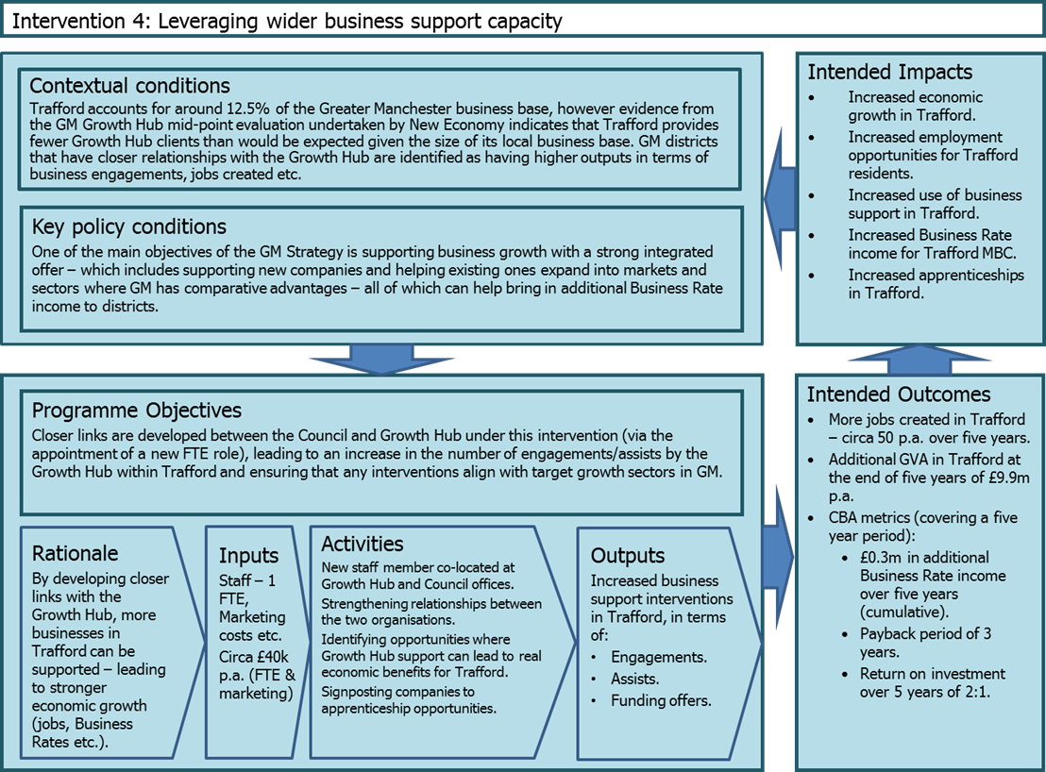
Intervention 4: Leveraging Wider Business Support Capacity

CBA Assumptions
Trafford accounts for around 12.5% of the GM business base, however evidence from the GM Growth Hub mid-point evaluation undertaken by New Economy indicates that Trafford provides fewer Growth Hub clients than would be expected given the size of its local business base – it accounted for 7.3% of jobs (131) created by the Growth Hub in 2014/15, for example.
Under this intervention, an FTE role will develop closer links between the Council and Growth Hub, leading to an increase in the number of engagements/assists by the Growth Hub within Trafford and ensuring that any interventions align with target growth sectors in GM. The FTE would also undertake a referral role in helping to signpost businesses to apprenticeship opportunities – contributing to the GM target of 180,000 new apprenticeship starts up to 2020 – and thus facilitating in upskilling the workforce. The cost associated with the role is estimated at £40,000 p.a., which includes 15% optimism bias. This is lower than the optimism bias used in a number of the other interventions, and reflects the fact that more robust information on salary bands at the Growth Hub is available.
In terms of benefits, we have assumed that jobs created will mirror Trafford’s share of the GM business base (12.5%). The number of jobs created by the Growth Hub in 2014/15 was just over 1,800 for GM as a whole, so this would lead to 225 in Trafford if it increased its share to 12.5% – an increase of 94. Allowing for deadweight (just under 50% based on official guidance), net jobs come out at 50 p.a.
Outputs
Over five years the outputs are estimated at:
Output | 2016/17 | 2017/18 | 2018/19 | 2019/20 | 2020/21
Jobs | 50 | 50 | 50 | 50 | 50
GVA | £1.98m | £1.98m | £1.98m | £1.98m | £1.98m
Business rates | £0.04m | £0.04m | £0.04m | £0.04m | £0.04m

The overall financial return of the intervention over a five year period is estimated at 1.61:1 by the CBA model – i.e. for every £1 put in, £1.61 is generated in benefits:
5 year time horizon | Trafford Fiscal Costs & Benefits | Public Value
Costs | £0.19m | £0.19m
Benefits | £0.3m | £16.2m
Return on investment | 1.61 | 86.45

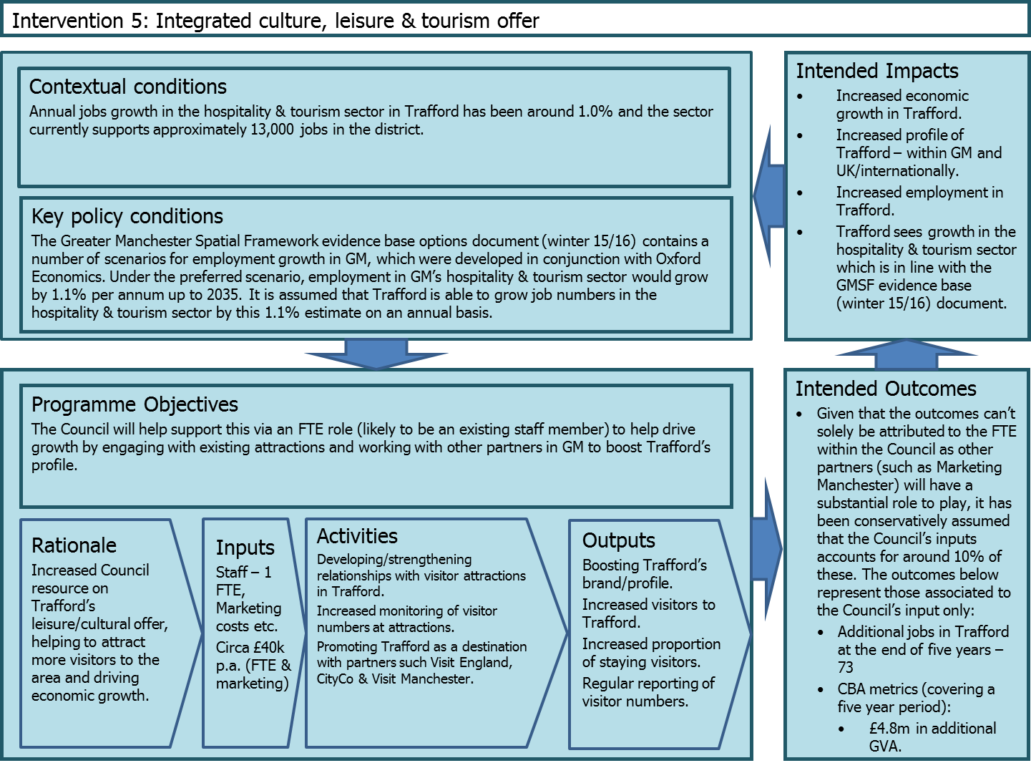

Intervention 5: Integrated Culture, Leisure and Tourism Offer
The latest data for 2014 sourced from the Business Register & Employment Survey (BRES) indicate that around 13,000 people work in the hospitality & tourism sector in Trafford, representing around 12% of all jobs in the sector in GM (107,000). The sector is defined by the following standard industrial classifications:
SIC Code(s) Description
55 Accommodation
56 Food and beverage service activities
79 Travel agency, tour operator and other reservation service and related activities
91 Libraries, archives, museums and other cultural activities
92 Gambling and betting activities
93 Sports activities and amusement and recreation activities

Between 2009 and 2014, employment in the hospitality & tourism sector in Trafford grew by 5.8% per annum. However, the main reason for this was a substantial increase in “sport activities and amusement & recreation activities” between 2012 and 2013 – which more than doubled to over 5,000. Annual jobs growth in the sector from 2009-13 was 1.0%. Given that BRES data can be subject to spikes in outputs, it makes more sense to focus on this lower annual growth rate.
The Greater Manchester Spatial Framework evidence base options document (winter 15/16) contains a number of scenarios for employment growth in GM, which were developed in conjunction with Oxford Economics. Under the preferred scenario, employment in GM’s hospitality & tourism sector would grow by 1.1% per annum up to 2035.
Under this intervention, it is assumed that the FTE role at the Council is able to support Trafford in growing job numbers in the hospitality & tourism sector by the 1.1% per annum discussed above. The annual cost of the FTE role at Trafford Council is assumed to be £40,000, which includes 15% optimism bias.
It is important to note that any growth would not solely be down to the FTE role, with input required by a number of stakeholders such as Marketing Manchester/Visit Manchester and the tourist attractions themselves, for example. Taking a conservative approach to the impacts, it is therefore assumed that the Council’s input accounts for around 10% of the increase in jobs and subsequent rise in GVA associated with the new employment opportunities.
Outputs
Over 5 years the in-year outputs associated with the Council (applying the 10% attribution) are estimated at:
Output | 2016/17 | 2017/18 | 2018/19 | 2019/20 | 2020/21
Additional Jobs | 14 | 14 | 15 | 15 | 15
GVA | £0.32m | £0.32m | £0.32m | £0.33m | £0.33m

We have calculated the fiscal benefits to Trafford by estimating the additional business rates that will result as a result of increasing GVA generated in Trafford. The overall financial return of the intervention over a five year period is estimated at 1:0.43 by the CBA model, i.e. for every £1 put in, £0.43 is generated in benefits. For the public value case we have considered the net additional GVA created as a result of increasing employment in the hospitality & tourism sector in Trafford. This results in a public value return on investment of 23.3:1.
To note, that the primary aim of this position is to increase the economic growth of Trafford as can be seen from the public value return on investment. It does also provide some additional income into Trafford Council through increased business rates, but this only partly offsets the cost of the post and this therefore shouldn’t be seen as a ‘spend-to-save’ initiative.
Financial Case
5 year time horizon | Trafford Fiscal Costs & Benefits
Costs | £0.19m
Benefits (business rates) | £0.08m
Return on investment | 0.43

Public Value Case
5 year time horizon | Public Value
Costs | £0.19m
Benefits (GVA) | £4.2m
Return on investment | 23.26

https://www.gov.uk/government/publications/supporting-public-service-transformation-cost-benefit-analysis-guidance-for-local-partnerships
Calculated by converting the GVA estimate into business rates using previous research undertaken by New Economy on the GM business base. This reflects an estimate of the proportion that will be retained by Trafford, although this is subject to a decision on future pooling arrangements across Greater Manchester and consultation with Government.
GVA, business rates and Council Tax are in-year estimates and are presented in 2014/15 prices.
Jobs have been averaged out at around 900 p.a. over the first 5 year period. Thereafter, jobs growth increases to more than 1,000 p.a. as it is assumed that more sites are developed and create new employment opportunities.
Presented as the total increase in business rates in Trafford. Details of how the increase in income will be apportioned to Trafford are unclear until future consultation with Government.
The costs set out in these tables relates primarily to staff costs within the existing SGS team and an estimate of associated professional and legal fees that may be required over the period.
See page 4 for definition of Public Value
GVA, business rates and Council Tax are in-year estimates and are presented in 2014/15 prices.
FTEs and associated costs are a subset of the previous intervention.
GVA, and business rates are in-year estimates and are presented in 2014/15 prices.
Average of 190 jobs p.a. over the first 5 year period, which is based on annual growth of 1.0%. Job numbers could then increase if Trafford sees annual growth of 1.5% after this period, as outlined in more detail in the third paragraph above.
See page 4 for definition of Public Value
Homes & Communities Agency, 2010: “Employment Densities Guide: Second Edition”; and English Partnerships, 2004: “A Standard Approach to Assessing the Additional Impact of Projects: Method Statement”
GVA, business rates and Council Tax are in-year estimates and are presented in 2014/15 prices.
It is assumed that development of the site does not start immediately and jobs have therefore been profiled over a 18 year period from 2018-2035.
See page 4 for definition of Public Value
Regeneris Consulting, January 2016: “Carrington Strategic Location: Socio-Economic Benefits Statement”
http://www.techuk-e.net/Portals/0/Content/ValleyofDeath/KTP%20Strategic%20Review.pdf
GVA, business rates and Council Tax are in-year estimates and are presented in 2014/15 prices.
See page 4 for definition of Public Value
The specific figure used is 47.2%. This relates to interventions targeted at supporting business development & competitiveness and is sourced from “Additional Guide: Fourth Edition 2014”. Homes and Communities Agency.
GVA, business rates and Council Tax are in-year estimates and are presented in 2014/15 prices.
See page 4 for definition of Public Value

